
Graduate School of Education

Doctor of Education (Ed.D.) Research Proposal

EFFECTS OF BIOLOGY-INFUSED DEMONSTRATIONS ON ACHIEVEMENT AND ATTITUDES IN JUNIOR COLLEGE PHYSICS

Charles CHEW Ming Kheng
B.Sc.(Hons), Post-Grad Dip.Ed. (Credit), M.Ed.(Hons)
Email: mkcchew@nie.edu.sg

National Institute of Education
Nanyang Technological University
1 Nanyang Walk, Singapore 637616

April 2005

Supervisors:

Dr. Elaine Chapman (Principal Supervisor)
Professor Tom O’Donoghue (Co-Supervisor)

Contents
Contents 2
Abstract 3
Introduction 4
Constructivism: The New Orthodoxy of Science Teaching? 5
Potential Benefits of Physics Demonstrations 6
The Predict-Observe-Explain Approach 7
Why Use Biology Examples in Physics Demonstrations? 8
Study Aims 9
Research Questions 10
Method 11
Research Approach 11
Participants 12
Research Design 13
Instruments 15
Physics Achievement 15
General Attitudes Towards Physics 16
Specific Affective Outcomes 17
Procedures 17
Data Analysis 18
Cognitive Outcomes 18
Affective Outcomes 19
Consent and Participants’ Protection 20
Significance 20
Major Scholars in the Field 21
Timeline 21
Facilities and Estimated Costs 22
Facilities 22
Estimated Costs 22
References 22
Appendices 27
Appendix A: Blueprints of Innovative Physics Demonstrations 28
Appendix B: Data Collection Questions 49
Appendix C: Physics Achievement Tests (PATs) 50
Appendix D: Test of Physics-Related Attitudes (TORPA) 85
Appendix E: Affective Outcomes Scale (AOS) 86

Abstract

This research will examine the effects of biology-infused physics demonstrations on the achievement and attitudes of junior college (Year 11 and 12) students in Singapore. Within each of two colleges, 120 participants (60 males and 60 females X 60 high and 60 low ability) will be assigned randomly into control and experimental groups (total n = 240). In both conditions, students will study two physics units under the constructivist teaching approach of Predict-Observe-Explain (POE). In the experimental group, however, biology-infused physics demonstrations will be used, whilst in the control group, more traditional demonstrations will be use. After two weeks of intensive physics demonstrations as enrichment lessons, these groups will be compared to examine the relative impact of these two approaches on physics achievement and attitudes. Gender and ability level will also be included in the model to determine whether the effects are consistent across these factors.

The outcomes of these two conditions will be assessed using three instruments: a Physics Achievement Test (PAT), a Physics Attitudes Survey (PAS), and an Affective Outcomes Scale (AOS). For data analysis, the statistical methods of Pearson r and Rasch will be used for the PAT, while factor analysis and MANCOVA will be used for the PAS and AOS. MANCOVA with pretest scores as covariates and Effect Sizes will also be used to study the main effects and interaction effects of the independent variables. This research study will be highly significant in that the findings may have national and international implications for the enhancement of physics education. This teaching-learning approach in infusing biology into physics demonstrations is likely to be the first of its kind in the Singapore context and possibly beyond. This research is also particularly timely, in light of the diminishing enrolments and interest of females in high school physics courses, as well as the reduced levels of physics achievement and attitudes’ of females in many countries.

Introduction

In Singapore, several important educational initiatives have been introduced in recent years that have direct implications for science education. These include:
- the promotion of interdisciplinary project work in 1999 - this initiative was designed to foster qualities such as curiosity, creativity and enterprise; nurture critical skills for the information age; cultivate habits of self-directed enquiry, and; encourage students to explore the inter-relationships between subject-specific knowledge (Ministry of Education, 1999/2000),
- the reform of life sciences in 2001 - this was done through a minor revision of syllabus and the production of resource books for primary, secondary and junior colleges which included life sciences activities. This reform was designed to equip students with the knowledge and skills for the growth area of life sciences in the real world, and
- the introduction of innovation and enterprise in 2003 – this initiatve aimed to prepare students for an innovation-driven future by equipping them with a key set of life skills, including a mindset and outlook of creativity, initiative and self-reliance, through the use of specific related learning activities.

Particular interest has been taken recently in the subject area of physics, which is typically characterized by problems of poor student enrolment. Traditionally, physics has been viewed by students as an abstract, ‘elitist’ subject area, and tends not to be preferred by lower-achieving science students (Stepans, 1991). Research has also suggested significant gender differences in preferences for physics at the secondary level. For example, in a study to explore the attitudes and perceptions of Scottish girls and boys towards physics over the age range of 10-18 years old, Reid and Skryabina (2003) reported that twice as many boys as girls were attracted to choose physics at the third year of the secondary school. Harding and Parker (1995) also reported that women are poorly represented in areas of employment that require science-related qualifications, except medicine. For example, in physics courses and examinations at school in England and Wales, girls are under-represented by factors of approximately 1:5 at GSE level, 1:3 at O level and 1:4 at A level. This underrepresentation of girls is then propagated into physics undergraduate courses (1:8), postgraduate courses (1:10) and professional activity as a physicist (1:20).

Haussler & Hoffmann (2002) cited an international survey by Gardner (1985, 1998) that “many studies repeatedly indicate that students’ interest in physics declines worldwide during Secondary Level 1 and that girls are less interested in physics than boys”. In the case of Germany, the enrolment of female students for physics achievement courses at upper secondary level fell to about 10% (Haussler & Hoffmann, 2002). In this intervention study involving six junior high schools in Germany, the following four different educational measures on intervention were used:
- adapting physics curriculum to interests of girls;
- training teachers in supporting girls to develop positive self-concept;
- splitting classes in half every second lesson and
- teaching girls and boys separately every second lesson.

Studies have also shown that gender differences in attitudes towards science may be discipline-specific. For example, results of the 1999 Third International Mathematics and Science Study (TIMSS) Benchmarking Study indicated significantly greater percentages of boys than girls with positive attitudes towards physics. The reverse, however, was true for the subject area of biology. Studies that have demonstrated relationships between poor engagement and failures to develop basic academic skills (e.g., Mathewson, 1994) highlight the potential significance of such attitudinal problems for physics as a subject area.

Constructivism: The New Orthodoxy of Science Teaching?

Many recent efforts to improve student engagement in secondary level science classrooms have been based on applications of constructivist learning principles. Constructivism has become the ‘buzz word of the day’ in science education. Since the mid-1980s, constructivism has become an increasingly popular theory of knowledge in the fields of both Mathematics and Science education (Chapman, 2003). As a theory of knowledge, constructivism is founded on the premise that by reflecting on our experiences, we construct our own understanding of the world in which we live. Research interest in constructivist teaching practices has generated a significant body of empirical data that has contributed to improving teachers’ knowledge and understanding of difficulties in the learning of science. The widespread acceptance of constructivism in many parts of the world led Mathews (1993) to label it as “the new orthodoxy of science teaching”.

Greer, Hudson, and Wiersma (1999, p.2) argued that, in general, constructivist teaching practices:
- provide learning experiences such as accessing students’ prior knowledge, utilizing reflective and relational thinking, and developing big ideas,
- create and capitalize on opportunities for student disequilibrium, misconceptions, and errors so that students are forced to query meaning, and
- provide opportunities for students to verbally interact with others in the pursuit of understanding and growth, enabling students to develop and support their own points of view rather than merely adopt the point of view of others, such as that of the teacher and the text/materials.

Potential Benefits of Physics Demonstrations

Recent increases of interest in the use of physics demonstrations have been prompted, at least in part, by the widespread adoption of constructivist learning approaches across many areas and levels of education. Albert Einstein once asserted that “in the matter of physics, the first lessons should contain nothing but what is experimental and interesting to see. A pretty experiment is in itself often more valuable than twenty formulae extracted from our minds” (cited in Moszkowski, 1970). Clifford and Thomas (1998), who acted as editors of The Physics Teacher for many years, noted further in their book Teaching Introductory Physics:
The demonstration experiment is one of the most powerful teaching tools that a physics teacher can call on. In a demonstration, an individual, usually the teacher handles objects in a planned way to illustrate or classify the physics to be taught... Teachers often find that returning alumni may say, “I remember when you showed us…,” but seldom or never reminisce about a lecture or a film. (p.8).

A search of issues from The Physics Teacher (http://scitation.aip.org/tpt/) between 1975 to 2004 shows that while several articles have been published on the design and use of physics demonstration experiments as teaching aids, few have examined the effects of these on achievement or affective outcomes in physics. Congruent with the ancient adage “seeing is believing” (Swartz & Miner, 1998), an effective physics lecture demonstration may foster students’ interest in the topic, as well as slowing the pace of teaching and affording students needed time to organise and digest the ideas presented to them.

Sund and Trowbridge (1973) proposed five types of demonstrations: teacher led (the teacher prepares and gives the demonstration), teacher-student led (a student assists the teacher in preparing and presenting the demonstration), student group led (the teacher acts as an evaluator of the demonstation), individual student led (the demonstration is given by a high-status student), and guest led (other science teachers or professional scientists are called in to present the demonstration).

Besides their potential motivational advantages, demonstrations may promote a scaffolding dimension in the comprehension and acquisition of abstract physics principles. Physics demonstrations can also promote skills in the use of essential equipment and direct/focus the thinking process by highlighting key concepts effectively.

Although very little research has been conducted on the efficacy of demonstrations on physics achievement, those that have been done generally indicate positive effects. In one recent example, Ciske (2002) examined the effects of student-led demonstrations in a high school physics class in Michigan. The nineteen students in the class were divided into two groups, one group who prepared and performed the physics demonstrations on eleven physics topics and one group who did not prepare and perform but observed the demonstrations. The results showed that the group who prepared and presented the demonstrations performed better on the post-test than the observers.

The Predict-Observe-Explain Approach

One useful structured constructivist teaching strategy which has direct relevance to the use of physics demonstrations is the Predict-Observe-Explain instructional approach (White & Gunstone, 1992). This approach incorporates elements of both teacher-centred and student-centred instruction. Predict-Observe-Explain [POE] (White & Gunstone, 1992) is a powerful strategy to conduct minds-on inquiry based demonstrations. In this approach, the teacher attempts to be a significant part of the learner’s lived experience. This is achieved through facilitating students’ reconstruction of their own knowledge in inquiry-based lessons by promoting interactions with objects in the environment, and engaging students in higher-level thinking and problem solving (Crawford, 2000).

POE includes the following five stages:
- teachers pose a problem for the students to predict the outcome of a demonstration before it is carried out;
- teachers ask students (in pairs) to make their personal predictions;
- students compare their predictions with each other before the conduct of the demonstration;
- students observe the demonstration as it is being carried out;
- students participate in a discussion facilitated by the teacher for purpose of teaching the correct scientific concepts and remediate any misconceptions.

Watts and Jofili (1998) cited Fox’s (1983) seven metaphors of a constructivist teacher which can be achieved through the constructivist POE instruction:
- Theatrical director – directs and orchestrates learners’ thinking,
- Tour guide – guides and chaperones learners,
- Scaffolder – provides structure and supports,
- Provocateur – challenges and struggles with the learner,
- Negotiator – acts as a broker between learner and curriculum,
- Committee chair – reconciles, organizes and manages goals and agendas, and
- Modeller – shapes and moulds learners’ knowledge.

Why Use Biology Examples in Physics Demonstrations?

Though the use of demonstrations at the junior college level in Singapore is already being practiced, these tend to be subject-specific, being largely restricted to physics, chemistry, or biology, with hardly any interdisciplinary demonstrations. One strategy that has some promise for meeting the goals of current educational initiatives within Singapore in the area of physics education is the infusion of biology into physics demonstrations.There are several reasons why infusing biology examples into physics demonstrations may prove to be an effective way of improving both performance and affective outcomes.

First, as indicated, one of the major goals of promoting interdisciplinary project work in science is to encourage students to explore the inter-relationships between subject-specific knowledge (Ministry of Education, 1999/2000). Scientific theories and models and students’ personal theories and models often conflict sharply with one another. The students’ personal theories and models may incorporate many “misconceptions” about the way the world works. They are referred to as “misconceptions” or “preconceptions” (Tao, Mak and Chung, 1986). Glynn, Yeany and Britton (1991) noted that students’ personal theories and models often work quite well in everyday life. It is only in science classrooms or laboratories that teachers can demonstrate the shortcomings of these misconceptions. Futther, however, students tend to ‘sectionalise’ their personal theories and models in order to protect them from the contractions they observe in the classroom. Reluctant to give up their preconceptions or even misconceptions, students may prefer to believe that some theories work fine in some contexts, but not in others. Drawing links between different discipline areas in science may be efficient, because it forces students to see that the principles introduced hold across different areas of application.

Second, while physics has been traditionally viewed as a somewhat ‘elitist’ subject area, biology has not. The gender differences in preferences for science at the secondary level also vary significantly with discipline area. Based on the 1999 TIMSS outcomes, higher percentages of boys demonstrate positive attitudes towards physics, while in biology, the reverse is true. It is possible that by infusing biology into physics demonstrations, and thus associating the two discipline areas, some of the differences previously seen in preferences for physics across ability levels and gender may be reduced.

Study Aims

In general, there is a dearth of research on the efficacy of using demonstrations in the subject area of physics. No research has been located which evaluates the efficacy of infusing examples from other areas such as biology within such demonstrations.

The major goal of this study was to design, develop, and evaluate an innovative teaching-learning approach based on physics demonstrations that infuse biology examples. This approach was designed to improve thinking skills by incorporating the major educational initiatives of innovation, information technology and interdisciplinary project work. The teacher-led physics demonstrations examined in this study are constructed using commonly available materials and/or equipment (including dataloggers) in the schools. The blueprints of these innovative demonstrations may, therefore, serve as useful educational resources for teachers to replicate within interdisciplinary projects.

The infusion of biology into physics demonstrations refers to the use of biological examples (eg. the human arm) instead of the usual non-biological examples (eg. a seesaw) to illustrate the same physics principles (eg. the principle of moments). In the study, the biology-infused approach will be compared with one that uses only the traditional non-biological examples. The two types of demonstrations will differ only with respect to whether they are infused with biology. Appendix A shows the blueprints (i.e., topic, syllabus outcome and pedagogical design) of four pairs of innovative physics demonstrations with and without the infusion of biology. These have been designed and are currently under further development by the researcher.

Of special interest in the study will be whether the impact of biology-infusion on achievement and attitudes differs across males and females. Increasing female students’ physics achievement and attitudes is of particular concern in high schools, in light of research that has indicated reduced levels of interest and enrolments in this subject area (Haussler & Hoffmann, 2002). With the infusion of biology into physics demonstrations, this study will also further examine the performance and attitudinal differences reported previously for males and females in secondary level physics classes (e.g., Gardner, 1985, 1998; Haussler & Hoffmann, 2002).

Research Questions

The primary reearch question to be addressed in the study is: What are the effects of infusing biology examples into physics demonstrations that are based on a constructivist teaching approach? Specific research questions are listed below (corresponding data collection questions are shown in Appendix B):
- What are the effects of using such demonstrations on physics achievement?
- What are the effects of using such demonstrations on physics attitudes?
- Do the effects of using such demonstrations on achievement and attitudes differ across males and females?
- Do the effects of using such demonstrations on achievement and attitudes differ across ability levels?

Method

Research Approach

In the book Developing Effective Research Proposals, published in 2000, a central issue in the whole field of empirical social research is the amount of structure and specificity planned into the research study. Studies may vary from tightly pre-planned and pre-structured to almost totally unfolding, with many positions between as shown in Figure 1 showing the continuum of the varying degrees of pre-structuring or unfolding.

Pre-specified research questions General open-ended questions Tightly structured design Loosely design
Pre-structured data Data not pre-structured
Qualitative
research

Quantitative
Research
Figure 1: Continuum of the varying degrees of pre-structuring or unfolding
(From Punch 2000, p.41)

As shown Figure 2, one of the key differences between the two types of research approaches (quantitative and qualitative) is the amount of pre-specified structure in the strategy used. Quantitative research approaches are generally used to address questions of effect (e.g., program evaluation studies). In this light, such studies are usually highly pre-structured, with clear and specific research questions, a clear conceptual framework, a pre-planned design and pre-coded data. On the other hand, qualitative research approaches generally focus on addressing questions of peoples’ perspectives. As such, these tend not to rely heavily on pre-structured questions, pre-planned designs and pre-coded data. In light of the fact that the major goal of this study was to evaluate the efficacy of the biology-infused demonstrations on physics achievement and attitudes, a quantitative approach was considered most appropriate.

Participants

The population from which the sample of two colleges will be taken is the fifteen junior colleges in Singapore. These are equivalent in level to Years 11 and 12 in the Australian system. Based on the annual school ranking of the fifteen junior colleges in academic performance, a purposive sampling of two colleges, one among the top five ranked colleges, and one among the bottom five ranked colleges, will be chosen. This is to ensure two groups of highly different ability students for maximum variation in the study.

In the Singapore system, all students receive an aggregate score on which decisions regarding college entry are made. This aggregate score is referred to as the mean L1R5, or the average students’ aggregate grades in L1 (English or Higher Mother Tongue) and five relevant subjects for admission to junior college. These scores give an indication of the intake quality of a junior college. The range of mean L1R5 scores is 6 to 20. Students are also assigned a mean subject grade (MSG). For computation of ‘A’ level subject grades, students are awarded grades A, B, C, D, E, O or F. A grade A is assigned a value of 1, B a value of 2 and so on. The mean subject grade (MSG) of a particular junior college is obtained by adding each of these values for each subject taken and dividing the sum by the total number of subjects taken. The lowest score for MSG is therefore 1 and the highest score is 7.

Table 1 below shows the intake quality of the two participating colleges in the study based on mean L1R5 scores. All colleges are also assigned a ranking position based on mean subject grades from the A level examinations. Table 4 shows the L1R5 scores and rankings for the two selected colleges out of fifteen from 2000 to 2002. As indicated, the mean L1R5 value of College B is almost double that for College A, confirming the large gap in the academic performance of the students in the two colleges. It also indicates that the mean L1R5 values and the ranking positions of the two selected colleges have remained relatively stable across the three years.

Table 1

Mean L1R5 and Rank Position
Year | College A  (Top-5 ranked) |  | College B  (Bottom-5 ranked)
 | Mean L1R5 | Rank Position | Mean L1R5 | Rank Position
2000 | 8.5 | 2 | 17.2 | 14
2001 | 8.3 | 3 | 16.4 | 14
2002 | 8.5 | 3 | 16.3 | 13

Research Design

Independent variables Dependent variables
Type of Demonstration Physics Achievement
Ability Level Physics Attitudes
Gender

Independent variables

(1) Type of Demonstration: There will be two levels of this independent variable: physics demonstrations with the infusion of biology, and physics demonstrations without the infusion of biology.
(2) Ability Level: There will be two levels of this variable, based on the mean L1R5 score.
(3) Gender: There will be two levels of this variable (male and female).
Dependent variables
(1) Physics Achievement: This refers to the scores of the students based on a 30-item, researcher-developed multiple-choice test.
(2) Physics Attitudes: This refers to scores on a researcher-adapted attitude survey comprising 25 statements to examine students’ attitudes towards physics.

The study will use an experimental design, with stratified random assignment of participants to conditions. Stratification variables will be gender and ability level. The design used in the study is represented in Figure 2.

Treatment No Treatment
(With the infusion of biology) (Without the infusion of biology)

Pre-test of
Experimental Group 60 participants (30 male and 30 female) from each college
Control Group 60 participants (30 male and 30 female) from each college
Attitudes &
Achievement

Post-test of
Attitudes &
Achievement

Figure 2. Diagrammatic representation of research design

For colleges A and B, using the mean L1R5 scores in Table 4, 120 first year students enrolled in the same ‘A’ level physics subject with L1R5 scores of 8 and 16 points will be randomly selected and assigned to either the experimental group or the control group. To examine gender effects, of the 120 students from each college, 60 will be female and 60 will be male. The total number of the participants in the study will be 240.

The following variables will be held constant across the two groups:
- Age: Same age group of 16 year olds junior college students taking the same GCE ‘A’ Level 9248 physics syllabus
- Gender Composition: Equal number of each gender from each of the two colleges
- Curriculum Content: Same selected topics on Forces, Dynamics, Electric Field, Capacitance and Current Electricity.
- Number of Demonstrations Used: All students will participate in four innovative physics demonstrations. In the experimental group, these will be biology-infused; in the control, they will be non biology-infused physics demonstrations will be based on the same physics principles in the prescribed syllabus.
- Teaching approach: In both conditions, the same modified Predict-Observe-Explain (POE) strategy will be used. The demonstrations used will be equivalent in terms of (i) the physics principles applied, (ii) application to real-life scenarios, (iii) basic structure and pedagogy, and (iv) difficulty level. The only difference between the conditions will be that the control condition will use traditional, physics-based examples, whereas the experimental condition will use biophysics examples.
- Number of enrichment sessions. In both conditions, students will all receive either two or three enrichment sessions, depending on the constraints of the college timetable.
- Timing of tests: Pre-test to be taken one month before the first lecture to minimise the practice effects. Post-test to be taken immediately on the day after the last lecture.

Instruments

Physics Achievement
To gather data for the evaluation of the effectiveness of two types of physics demonstrations in improving achievement in physics among junior college students in Singapore, a Physics Achievement Test (PAT) is currently under development by the researcher. Appendix C shows two sets of alternate or parallel forms of the PAT that have been developed to be piloted for validity and reliability with the aim of selecting the best items to construct the final PAT. ‘Alternate forms’ are simply different versions of a test that have been constructed so as to be parallel. They are designed to be equivalent with respect to variables such as content and level of difficulty. ‘Parallel forms’ of a test exist when for each form of the test, the means and variances of observed test scores are equal. The format of this final PAT written test will comprise 30 Multiple Choice Questions (MCQ). To ensure a good linkage between the PAT and the two types of physics demonstrations, these 30 MCQs will be divided into the following 3 sections of 10 questions each:
- Section 1 will be based on common background knowledge based on the physics syllabus
- Section 2 will be based on real-life applications which do not involve biology and
- Section 3 will be based on real-life applications which involve biology.

These physics questions will be chosen or modified from previous year questions and established “A” level and university textbooks to test conceptual understanding, thinking skills and application to real life situations. The rationale for choosing questions from past year GCE ‘A’ level examination papers is that these questions are set by an internationally recognised examination board, University of Cambridge-London Examination Syndicate (UCLES).

To ensure content validity in the construction of the MCQ items in the Physics Achievement Test (PAT), the questions have been constructed based on the learning outcomes of the physics topics prescribed in the syllabus. The professional judgement of the senior physics teachers of the two participating colleges as well as content experts from the National Institute of Education will also be sought.

To test for reliability, the ‘parallel-forms’ or ‘alternate-forms’ with a time interval of 1-3 week(s) together with split ordering will be administered to two groups of 20 participants from colleges A and B respectively. The two groups of 20 participants will comprise 10 males and 10 females. These 40 participants from each college will be drawn from the prior batch of Year 1 students to ensure that they have completed the topics covered in the PAT. In addition, the conduct of the pilot study at both the participating colleges will ensure that the succeeding batch of 120 Year 1 students who will participate in the main or actual study have undergone the same instructional programme and college environment. The purpose of the 1-3 week(s) test-retest is to check the instrument’s reliability across time.

General Attitudes Towards Physics
A modified version from an existing well-established instrument, Test of Science-Related Attitudes questionnaire (TOSRA) (Fraser, 1981; Fisher, Henderson and Fraser, 1995), will be used to assess general attitudes towards physics. The full TOSRA includes items which measure seven distinct facets of science-related attitudes (Social Implications of Science, Attitude towards Scientific Inquiry, Adoption of Scientific Attitudes, Enjoyment of Science Lessons, Normality of Scientists, Leisure Interest in Science and Career Interest in Science). In this study, only the Enjoyment of Science Lessons scale will be used, as this is the only subscale deemed to be relevant given the content of the interventions used. Thus, from the original TOSRA, only seven items will be used. In the scale, the word ‘science’ will be replaced with ‘physics’ to ensure that responses are specific to this subject area. Another change made will be the reduction of the original 5 responses to 4 responses by deleting the ‘not sure’ response for all the seven items. Thus each item will have four-scaled options: SA strongly agree, A agree, D disagree and SD strongly disagree. Appendix D shows the Test of Physics-Related Attitudes (TORPA), which is a modified version of the TOSRA.

Specific Affective Outcomes

In addition to a measure of general attitudes, a measure will be developed and used to assess students’ specific perceptions of the physics demonstrations. This may provide a more sensitive measure of differences between the two study conditions. Given that there is, at present, no measure that specifically targets responses to science demonstrations, a measure has been constructed by the researcher to assess these. The Affective Outcomes Scale (AOS) constructed (see Appendix E) is designed to reflect students’ responses to the demonstrations used in the study in terms of their utility in terms of (i) facilitating understanding of the subject matter, (ii) enhancing enjoyment and interest in the subject matter, and (iii) emphasising the potential importance of the subject matter.

Procedures

The access to students’ registers will provide the essential data of population size, gender, L1R5 entry scores and subject combinations. For the purpose of the pilot study to test the validity and reliability of the instruments PAT and AOS, the population of the students in each college will be divided into two lists by genders with a range of L1R5 scores for the prior batch of Year 1 students of college A and college B respectively. The required number of 20 male participants and 20 female participants from each college will then be randomly chosen by taking at fixed intervals in the list.

For the actual study involving the 120 succeeding batch of first year students from each college, the population of the students in each college will be divided into two lists by genders with the same L1R5 score of 8 points and 16 points. Based on the pre-test scores, stratified random assignment into the experimental and control groups with equal number of male and female participants will be carried out. An analysis of variance on pretest scores will be made to ensure that the participants in both the experimental and control groups are not different.

As the pilot study is targeted at the prior batch of Year 1 junior college students, a good period will be before their final examinations sometime in July to August period. For the actual study which is targeted at the succeeding batch of Year 1 junior college students who are new to the lecture tutorial system, it is important for them to get inducted into this mode of learning and to have completed those topics that are selected for this research study before taking the pre-test. A sufficient time lag of a month between conducting the pre-test and the post-test must also be factored in to minimize the practice effect. In the light of the above considerations, a good period for the pre-test would be sometime in November after their promotional examinations or latest early January of the following year. The conduct of the two week intensive physics demonstrations as enrichment lessons can be carried out in February of the following year to be immediately followed by the post-test.

The ‘dead’ time of the first semester and the early half of the second semester will be used to construct and test the demonstrations followed by a training session to equip the two senior physics teachers from each college on the POE constructivist teaching approach in the conduct of the physics demonstration lectures with and without the infusion of biology. To remove the teacher effect in the study, both the teachers will lecture half of the control group and half of the experimental group.

Data Analysis

Cognitive Outcomes
As indicated, the content validity of the two parallel forms of the Physics Achievement Test (PAT) will be evaluated through expert panels. The psychometric properties of the instrument will be further examined and improved through the pilot study conducted in July/August, 2005. On the basis of the 80 students who complete the two parallel forms of the test during this phase, the characteristics of each multiple choice item and the overall structure of the test will be examined using Rasch methods. This process will be used to examine whether any items should be excluded in either of the final forms of the instrument. Based also on the pilot study data, the reliability of the instrument will be estimated using (i) internal consistency indices within each of the three subdomains, based on Cronbach’s alpha, and (ii) test-retest indices, based on the correlation between scores from the first and the second test administrations. If either index suggests a low reliability, the test forms will be reworked prior to use in the final study.

A multivariate analysis of covariance (MANCOVA) will be performed to determine whether there was a significant difference in the post-test achievement of the experimental and control groups. As indicated, half of the participants in each of the colleges will take Form I at pre-test and Form II at post-test, with the remaining half taking the two forms in the reverse order. To ensure that test order does not influence the results, a 2 (condition: experimental versus control) by 2 (college: A versus B) by 2 (test order: Form_{I,II} versus Form_{II,I}) factorial design will be used in the MANCOVA (n = 30 per cell). If there are no significant interaction effects involving test order, the analysis will be collapsed to a 2 by 2 design. The three dependent measures will be scores for the three subdomains within the tests (common theory, real-life physics-based applications, real-life biophysics-based applications). Pretest scores for the three corresponding subdomains will be entered as covariates to take into account individual differences on the pretest and to reduce within-condition error variance in the posttest scores. All relevant underlying assumptions will be tested prior to conducting the analysis, and all significant MANCOVA outcomes will be accompanied with an index of effect size (the partial η² statistic) to indicate the percent of variance in scores for which the intervention accounts.

Affective Outcomes
As indicated, a modified version of the Test of Science-Related Attitudes (TOSRA) will be used both at the pre-test and at the post-test. At post-test, an additional measure (the Affective Outcomes Scale, AOS) will be used to assess students’ affective responses specifically to the demonstrations. Given that the AOS cannot be pilot-tested (as it refers specifically to the demonstrations used in the study), a relatively large number of items will be included to allow for some attrition in the analysis stage. To examine the structure of the AOS, post-test scores for the 240 participants will be intercorrelated and subjected to an exploratory factor analysis. Maximum likelihood estimation will be used in the initial extraction of factors, with an oblique rotation (Direct Oblimin) used to enhance interpretability of the resulting factor loadings. On the basis of this analysis, subscale scores will be formed for the purposes of further analysis.

Following this, a MANCOVA will be performed to determine whether there was a significant difference in the post-test TOSRA and AOS subscale scores of the experimental and control groups. In this case, as there will be no pre-test scores for AOS, the pre-tests for the TOSRA will be used as covariates. Again, all relevant underlying assumptions will be tested prior to conducting the analysis, and all significant MANCOVA outcomes will be accompanied with an index of effect size (the partial η² statistic).

Consent and Participants’ Protection

A formal visit will be made to obtain the support of the principals of the two selected junior colleges for both the pilot study and the actual study. An information sheet and consent letter for Physics Heads and the participating students in this research study will be provided through the principals. No reference will be made to individual results in the analysis of the data. To safeguard the confidentiality of the participating colleges, the names of the colleges will be coded as College A and College B.

Significance

The outcomes of this study may have national and international implications for the enhancement of physics education through the use of demonstrations. The teaching-learning approach evaluated here is likely to be the first of its kind in the Singapore context and possibly beyond. This research is also particularly timely, in light of the falling enrolment and interest of females in high school physics courses, and the lower physics achievement and attitudes of females in many countries.

At the national level, the introduction of this innovative teaching-learning approach has the potential to (i) contribute to physics education at the junior college, (ii) contribute to the transformation of Singapore schools into thinking schools for the new millennium, and (iii) provide a blueprint for the design and development of customised physics demonstrations that include the infusion of examples from biology. It is hoped that this blueprint will, in turn, be used as resource to promote meaningful interdisciplinary project work in physics.

In the international context, the research findings on the efficacy of physics demonstrations with the infusion of biology on physics achievement and attitudes could have important implications such as the provision of alternative pathways to the transmission of knowledge as well as the narrowing of the gender gap in physics achievement. This could, in turn, lead to improved attitudes towards physics and improved enrolment of female students in physics courses and physics-related career paths.

Major Scholars in the Field

Dr Thomas O’Brien
Associate Professor
School of Education & Human Development
Binghamton University
State University of New York

Dr Julien C. Sprott Professor of Physics Department of Physics University of Wisconsin

Timeline

2004
- Initial Literature Review
- Preparation of Initial Research Proposal
- Identification of the two colleges for research study
- Initial visit to the two colleges for discussion with the principals and physics heads
- Design and development of both types of demonstrations
- Development of Physics Achievement Test (PAT)
- Sourcing of Physics Attitude Scale (PAS)
- Finalising of Research Proposal
- Ongoing literature Review
2005
- Finalising the design and development of the demonstrations
- Finalising the instruments PAT and PAS for piloting
- Final visit to the two colleges for discussion with the principals and physics heads
- Drawing of schedules for the period and duration of the pilot and actual study
- Selection and recruitment of participating teachers and students
- Piloting of instruments PAT and PAS for validity and reliability
- Training of participating teachers in the conduct of the demonstrations
- Finalising the instruments PAT and PAS for actual research study
2006
- Implementation of the demonstration lessons for data collection
- Analysis of data
- Preparation of initial draft of thesis
2007
- Submission of final thesis

Facilities and Estimated Costs

Facilities

Physics Laboratory for the design, development and testing of the demonstrations.
Lecture theatres of the two participating colleges with audio and visual equipment.

Estimated Costs

Estimated costs will be approximately $3000 for the materials in the design and development of the customized demonstrations, token of appreciation for all participants, photocopying of literature readings, achievement test and questionnaire for students.

References

Bottery, M. (1999). Global forces, national mediations and the management of educational institutions. Educational Management & Administration, 27(3), 299-312.
Cameron, R.C., Skofronick, J.G. (1978). Medical Physics. New York: Wiley & Sons, Inc.
Campbell, D.T. and Stanley, J.C. (1963). Experimental and Quasi-Experimental Designs for Research. Chicago: Rand McNally.
Chapman, A.P. (2003). Language Practices In School Mathematics: A Social Semiotic Approach. United States of America: The Edwin Mellen Press, Ltd.
Ciske, P.B. (2002). The Effectiveness of Student-led Demonstrations in a High School Physics Class. Published Master of Science Thesis. United States of America: Michigan State University.
Cohen, R.J., Montague, P., Nathanson, L.S. & Swerdlik, M.E. (1988). Psychological Testing: An Introduction to Tests & Measurement. United States of America: Mayfield Publishing Company.
Crawford, B.A. (2000). Embracing the essence of inquiry: New roles for science teachers. Journal of Research in Science Teaching, 37 (9), 916-937.
Dudley, J. & Vidovich, L. (1995). The Politics of Education: Commonwealth schools policy 1973-95. Camberwell, Vic: ACER. (chapter 2).
Fisher, D., Henderson, D., and Fraser, B. (1995) 'Interpersonal behaviour in senior high school biology classes', Research in Science Education, 25(2): 125-133.
Fox, D. (1983). Personal theories of learning. Studies in Higher Education, 8 (2), 151-163.
Fraser, B.J. (1981) Test of attitudes of science-related attitudes. Australian Council for Educational Research, Hawthorn, Australia.
Gardner, P.L. (1985). Students’ attitudes to science and technology: An international overview. In: Lehrke, M., Hoffmann, L., & Gardner, P.L. (Eds.), Interests in science and technology education (pp. 15-34). IPN-Schriftenreihe 102. Kiel: Institute for Science Education (IPN).
Gardner, P.L. (1998). The development of males’ and females’ interests in science and technology. In Hoffmann, L., Krapp, A., Renninger, K.A., & Baumert, J. (Eds.), Interest and learning (pp. 41-57). IPN-Schriftenreihe 164. Kiel: Institute for Science Education (IPN).
Glynn, S.M., Yeany, R.H. & Britton, B.K. (1991). A constructivie View of Learning science. In Glynn, T., Yeany, A., & Britton, E. (Eds.), The Psychology of Learning Scicence. New Jersey: Lawrence Erlbaum Associates.
Green, A. (1999). Education and globalization in Europe and East Asia: Convergent and divergent trends. Journal of Education Policy, 14(1), 55-71.
Greer, M.A., Hudson, L.M., & Wiersma, W. (1999). The Constructivist Teaching Inventory: A new instrument for assessing constructivist teaching practices in the elementary grades. Paper presented at the Annual Meeting of the American Educational Research Association, Montreal, Canada, April 19-23.
Harding, J. & Parker, L.H. (1995). Agents for change: policy and practice towards a more gender-inclusive science education. International Journal of Science Education, 17 (4), 537-553.
Haussler, P., Hoffmann, L. (2002). An Intervention Study to Enhance Girls’ Interest, Self-Concept, and Achievement in Physics Classes. Journal of Research in Science Teaching, 39 (9), 870-888.
Hobbie, R.K. (1988). Intermediate Physics for Medicine & Biology. 2nd edn. New York: John Wiley & Sons, Inc.
Martinez, M.E., Haertel, E. (1991). Components of Interesting Science Experiments. Science Education, 75 (4), 471-79.
Marzano, R.J., Brandt, R.S., Hughes, C.S., Jones, B.F., Presseisan, B.Z., Rankin, S.C. and Suhor, C. (1998). Dimensions of Thinking: A Framework for Curriculum and Instruction. Association for Supervision & Curriculum Development, 147 – 48.
Matthews, M.R. (1993). Constructivism and science education: Some epistemological problems. Journal of Science Education and Technology, 2, 359 – 370.
Mathewson, G. C. (Ed.). (1994). Model of attitude influence upon reading and learning to read. Newark, DE: International Reading Association.
Ministry of Education. (1999/2000). MOE Yearbook. Singapore: Ministry of Education.
Ministry of Education. (1958). Syllabus for Science. Singapore: Ministry of Education
Ministry of Education. (2001). Science Syllabus. Singapore: Ministry of Education.
Ministry of Education. (2003). Science Syllabus. Singapore: Ministry of Education.
Moszkowski, A. (1970). Conversations with Einstein. New York: Horizon Press.
Ozga, J. (2000). Policy Research in Educational Settings: Contested terrain. Buckingham: Open University Press. (chapter 1).
Punch, K.F. (1998). Introduction to Social Research. Bonhillstreet London: SAGE
Punch, K.F. (2000). Developing Effective Research Proposals. Bonhillstreet London: SAGE.
Punch, K.F. (2003). Survey Research: The Basics. Bonhillstreet London: SAGE.
Reid, N. & Skryabina, E.A. (2003). Gender and physics. International Journal of Science Education, 25 (4), 503-536.
Stepans, J. (1991). Developmental patterns in students’ understanding of physics concepts. In Glynn,T., Yeany, A., & Britton, E. (Eds.), The Psychology of Learning Science. New Jersey: Lawrence Erlbaum Associates.
Sund, R.B., Trowbridge, L.W. (1973). Teaching Science by Inquiry in the secondary school. 2nd edn. Ohio: Merrill.
Swartz, C.E. & Miner, T. (1998). Teaching Introductory Physics: A Sourcebook. United States of America: Springer-Verlag New York, Inc.
Tabachnick, B.G. & Fidell, L.S. (2001). Using Multivariate Statistics. 4th edn. United States of America: Allyn & Bacon.
Tao, P.K., Mak, S.Y., & Chung, C.M. (1986). A study of school children's alternative frameworks of the particulate theory of matter. Research report, the Chinese University of Hong Kong.
Tobin, T. (1993). The Practice of Constructivism in Science Education. New Jersey: Lawrence Erlbaum Associates, Inc.
Toh, K.A., Ho, B.T., Chew, M.K.C. & Riley, J.P. (2004). Teaching, Teacher Knowledge and Constructivism. Educational Research for Policy and Practice, 2 (3), 195-204.
Watts, D. M., & Jofili, Z. (1998). Towards critical constructivist teaching. International Journal of Science Education, 20 (2), 173-185.
White, R., & Gunstone, R. (1992). Probing understanding. London: Falmer Press.
Willson, V.L., Ackerman, C., Malave, C. (2000). Cross-Time Attitudes, Concept Formation, and Achievement in College Freshman Physics. Journal of Research in Science Teaching, 37 (10), 1112-20.
Yager, R. (1991). The constructivist learning model: Towards real reform in science education. The Science Teacher, 58 (6), 52 – 57.
Yip, J., Eng, S.P., Yap, J., Lim, S.T., Gopinathan, S., Ang, W.H. and Yeoh, O.C. (1990). Evolution of Educational Excellence: 25 years of Education in the Republic of Singapore, (Yip J & Sim WK, eds).Longman Singapore Publishers (Pte) Ltd.

http://scitation.aip.org/tpt/: The Physics Teacher

http://isc.bc.edu/timss1999b/sciencebench_report/t99bscience_chap_1_3.html: 1999 Third International Mathematics and Science Study (TIMSS).

http://www.pky.ufl.edu/~gjones/surveypaper.htm: University Students' Attitudes Towards Physics (Jones, T.G., 1998)
http://www.moe.gov.sg/corporate/primary3.htm: Flowchart of the Education System.

http://www.moe.gov.sg/corporate/desired_outcomes.htm: Desired Outcomes of Education.
http://www.moe.edu.sg/abtmoe/pa/contact/vol10/pers.htm : Speech by Prime Minister Goh Chok Tong at the opening of the 7th International Conference on Thinking on Monday, 2 June 1997.
http://www1.moe.edu.sg/press/1998/5sep98.htm: Ministry of Education's inaugural Work Plan Seminar on Education in Schools held on Saturday, 5 September 1998.
http://sprott.physics.wisc.edu/demobook/intro.htm: A Sourcebook for Teachers of Physics.
http://intranet.moe.gov.sg/cpdd/: Process Skills, Ministry of Education.
http://www.moe.edu.sg/exams/html/syllabus.htm: Examination Syllabus, Singapore: Ministry of Education.
http://www1.moe.edu.sg/esd/index.htm : Performance indicators for Secondary Schools and Junior Colleges

Appendices

Appendix A: Blueprints of Innovative Physics Demonstrations
Blueprints of Innovative Physics Demonstrations

A typical design blueprint consists of three parts, namely, topic, syllabus outcome and the pedagogical design. This is illustrated below in the four pairs of innovative physics demonstrations.

1. First pair of special physics demonstrations
Part 1: Topic: Forces
Part 2: Syllabus Outcome: Apply the principle of moments
Part 3: Pedagogical Design:
(A) Common background knowledge for both control and experimental groups:
- For a rigid body to be in translational equilibrium, the vector sum of the forces acting on it must be zero.
- For a rigid body to be in rotational equilibrium, the vector sum of the torques acting on it must be zero.
- Common theoretical application for both control and experimental groups:
upward force
hinge
(unknown upward/downward
force at the hinge )
weight load

This theoretical application will serve to equip the participants from both the control and experimental groups with the same knowledge and skills before they are exposed to the two different types of physics demonstrations that use the same knowledge and skills.
(C) Real-life application for control group: Pivoting a wooden pole in a hollow tube with a load at the end

Apparatus: Wooden pole, hollow aluminium tube, two retort stands, weights
Demonstration set-up:
downward force
hollow tube wooden pole

upward force weight load

(D) Real-life application for experimental group: Human arm holding a load
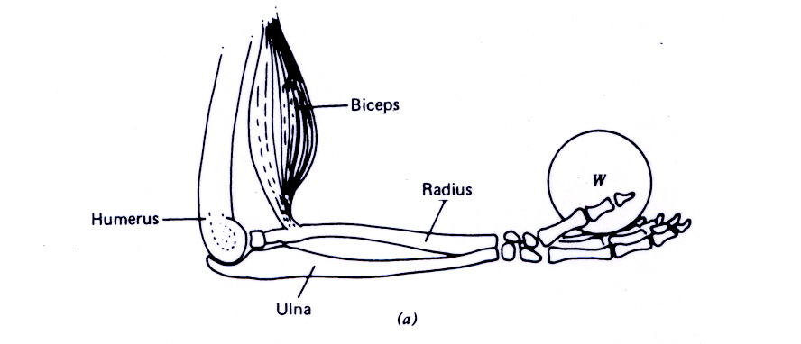
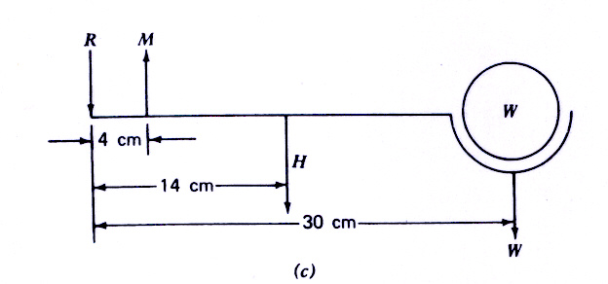

The forearm muscle and bone system Forces acting on the forearm
The forces acting on the forearm are as follows:
- R: reaction force of the humerus on the ulna,
- M: muscle force supplied by biceps,
- H: weight of the tissue and bones of the hand
- W: weight of object in the hand

Apparatus: Two pieces of perspex of different colours, two force sensors connected to computer with the relevant software, two retort stands, weights

Demonstration set-up:
Large piece of perspex of one colour

fixed pivots
Force sensors connected to computer

perspex of another colour for constrast

movable pivot
weight weight

2. Second pair of special physics demonstrations
Part 1: Topic: Dynamics
Part 2: Syllabus Outcomes:
(1) Show an understanding that mass is a property of a body which resists change in motion.
(2) Define force as rate of change of momentum F = (Δmv)/Δt
(3) Recall and solve problems by using the relationship F = ma, appreciating that acceleration and force are always in the same direction.
Part 3: Pedagogical Design:
(A) Common background knowledge for both control and experimental groups:
(1) Newton’s 1st Law of Motion:
Every body continues in its state of rest or uniform motion in a straight line unless a net external force acts on it to change that state.

(2) Newton’s 2nd Law of Motion:
The rate of change of force acting on a body is directly proportional to the net force acting on it and takes place in the direction of the force.
In equation form:
F = (Δmv)/Δt
For constant mass m, the equation becomes:
F = (Δmv)/Δt = m (Δv)/Δt = ma where a is the acceleration
- Newton’s 3rd Law of Motion:
When two bodies interact, they exert equal and opposite forces on one another.
(B) Common theoretical application for both control and experimental groups:
Question:
A construction worker walking at a speed of 1 m/s hit accidentally knocks his head onto a concrete beam.
(a) If the mass of the head is 5 kg and the duration of impact before the head comes to a stop is 0.01 s, calculate the average force exerted on his head by the concrete beam.
(b) If the concrete beam has a padding and the duration of impact before the head comes to a stop is 0.05 s, what is the average force exerted on his head by the padded concrete beam?
(c) Comment on the difference in the two average forces in (a) and (b).
Solution
(a) Concrete beam
Average force F₁ = m (Δv)/Δt = [(5 kg) (1 m/s – 0 m/s)]/ 0.01 s = 500 N

(b) Padded concrete beam
Average force F₂ = m (Δv)/Δt = [(5 kg) (1 m/s – 0 m/s)]/ 0.05 s = 100 N
(c) Comment
The reason for F₁ being 5 times larger than F₂ is due to the shorter time of impact of 0.01 s with the concrete beam compared to 0.05 s with the padded beam
(C) Real-life application for control group:
Scenario 1: A moving bus colliding into a concrete wall without padding.

concrete wall
Scenario 2: A moving bus colliding into a concrete wall with padding.
padding
concrete wall
Apparatus: trolley, ramp, force sensor, brick, padding
Demonstration set-up:
Scenario 1
force sensor to computer
brick
trolley
ramp

Scenario 2
force sensor to computer
brick
trolley
ramp
padding

(D) Real-life application for experimental group:
Scenario 1: Whiplash effect of collision on a driver on a concrete wall
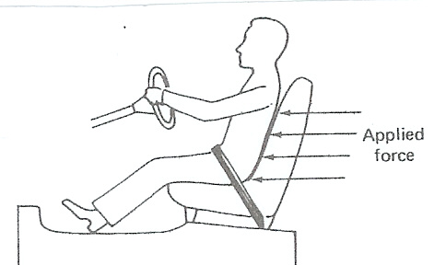

concrete wall

(a) Upon impact with the wall
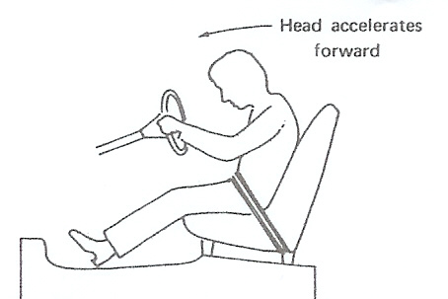
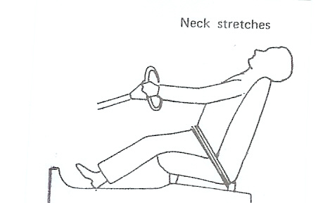

(b) Effect on the head of driver (c) The next moment
Scenario 2: Whiplash effect of collision on a driver on a concrete wall with
padding
padding

(a) Upon impact with the padded wall

(b) Effect on the head of driver (c) The next moment
Apparatus: dummy with a coil of spring connecting head to body, ramp, trolley, 2 force sensors, brick, padding
Demonstration set-up:
Scenario 1
force sensors to computer
brick
trolley
ramp
coil of spring

Scenario 2
force sensors to computer
brick
trolley
ramp
coil of spring

Close-up picture of dummy in the trolley

3. Third pair of innovative physics demonstrations
Part 1: Topic: Viscous Fluids
Part 2: Syllabus Outcomes: apply Stokes' law to explain quantitatively how a body falling through a viscous fluid under laminar conditions attains a terminal velocity.
Part 3: Pedagogical Design:
(A) Common background knowledge for both control and experimental groups:
1. Viscous Drag
The drag force F on a moving sphere under laminar conditions in a viscous fluid is given by Stokes’ Law: F = Arηv where
A is a dimensionless constant which has a value of 6π;
r = radius of the sphere;
η = coefficient of viscosity &
v = speed of the moving sphere
2. Stokes’ Law & Terminal Velocity
(a) When a small steel ball of mass m and radius r is released in a viscous liquid such as glycerine, it accelerates from rest and soon attains a steady maximum value known terminal velocity v_{T} .
(b) At terminal velocity, Upward viscous drag force + Upthrust = Weight of steel ball
6πηr v_{T} + (4/3) πr³ρ_{l} g = (4/3) πr³ρ_{s} g
where ρ_{l} & ρ_{s} are the densities of the liquid and sphere respectively.
Therefore, v_{T} = [2gr² (ρ_{s} - ρ_{l}) ] / 9η

(B) Common theoretical application for both control and experimental groups:
Question
A spherical dust particle of diameter 2 x 10⁻⁵ m and density 2 x 10³ kg m⁻³ falls
freely through air under the pull of gravity. Given that the density and viscosity of
air are 1.20 kg m⁻³ & 1.81 x 10⁻⁵ Pa s respectively, calculate , taking g = 10 m s⁻² , the
(i) terminal velocity of the dust particle,
(ii) viscous drag force at terminal velocity assuming Stokes’ Law holds true,
Solution
(i) Given: diameter 2r = 2 x 10⁻⁵ m from which radius r = 1 x 10⁻⁵ m
density of dust particle, ρ_{d} = 2 x 10³ kg m⁻³
density of air, ρ_{a} = 1.20 kg m⁻³
viscosity of air, η = 1.81 x 10⁻⁵ Pa s
At terminal velocity v_{T} ,
Upward viscous drag force + Upthrust = Weight of the dust particle
6πηr v_{T} + (4/3) πr³ρ_{a} g = (4/3) πr³ρ_{d} g where ρ_{a} & ρ_{d} are the densities of the air and dust respectively.
Therefore, v_{T} = [2gr² (ρ_{d} - ρ_{a}) ] / 9η
= [2 (10) (1 x 10⁻⁵)² (2 x 10³ -1.20)] / 9 x 1.81 x 10⁻⁵
= 2.45 x 10⁻² m s⁻¹
(ii) Using Stokes’ Law, viscous drag force at terminal velocity,
F = 6πrηv
= 6π x 1 x 10⁻⁵ x 1.81 x 10⁻⁵x 2.45 x 10⁻² = 8.36 x 10⁻¹¹ N

(C) Real-life application for control group:
Scenario
Parachutists of different weights released from rest will free-falling in air under decreasing acceleration and reach different terminal velocities.
Apparatus: Small umbrella as parachute, three toys of different weights, strings, pendulum as counterweight, smart pulley connected to computer
Demonstration set-up:
To computer
smart
pulley

parachute (umbrella)
strings

toy

Pendulum as counterweight

(D) Real-life application for experimental group:
Scenario
Medical physics has found that for people suffering from certain diseases such as rheumatic fever, rheumatic heart disease and gout, the red blood cells clump together and the effective radius increases. In other diseases such as hemolytic jaundice and sickle cell anemia, the red blood cells change shape or break and the effective radius decreases. Different size ball bearings (representing blood cells of different radii) released from rest will free-falling in air under decreasing acceleration and reach different terminal velocities.
Apparatus: Three different size ball bearings, tall and wide transparent jar, glycerine/dish washing liquid, rubber bands, stopwatch, ruler, calculator
Demonstration set-up:

ball bearing released from top of jar

Marker A

Marker B

Rubber bands at
equal distances
to act as markers
Marker C

liquid
Marker D

With the help of a stop watch, find the three time intervals for a free-falling ball bearing passing through the same distance between markers A and B, markers B and C and markers C and D. Divide the distance with the each of the time intervals to find the average velocities at between the markers A and B, B and C and C and D. You will notice that the velocity of the ball bearing will increase from a small value to a terminal value. In addition, different sized ball bearings will have different the terminal velocities.

4. Fourth pair of innovative physics demonstrations
Part 1: Topic: Current of Electricity, Electric Field and Capacitance
Part 2: Syllabus Outcomes:
(1) show an understanding that electric current is the rate of flow of charged particles.
(2) distinguish between e.m.f. and p.d in terms of energy considerations.
(3) solve problems by using the formula for the combined resistance of two or more resistors in series.
(4) solve problems using the formula for the combined resistance of two or more resistors in parallel.
(5) show an understanding of the use of a potential divider circuit as a source of variable p.d.
(6) show an understanding of the concept of an electric field as an example of a field of force and define electric field strength as force per unit positive charge.
(7) calculate the field strength of the uniform field between charged parallel plates in terms of potential difference and separation.
(8) show an understanding of the function of capacitors in simple circuits.
(9) define capacitance and the farad.

Part 3: Pedagogical Design:
(A) Common background knowledge for both control and experimental groups:
(1) Current I is a measure of the rate of flow of electric charge Q. Conventionally, the direction of the electric current is taken to be the positive charge flow direction.
(2) Electromotive force (emf): rate of transformation of energy from non-electrical to electrical per unit current delivered by the source
(3) Potential difference V: rate of dissipation of electrical energy per unit current flow
(4) Electric field strength E is defined as the electrostatic force acting per unit positive charge. For two parallel charged plates, the electric field E = V/d where V is the potential difference between the plates and d is the separation between the plates.
(5) Capacitance C is a measure of the charge storing ability of a conductor. Capacitance C of a conductor is defined as C = Q/V which is the charge required to cause unit change in the potential of a conductor.
(B) Common theoretical application for both control and experimental groups:
(1) Parallel plate capacitor
Charging of a parallel plate capacitor
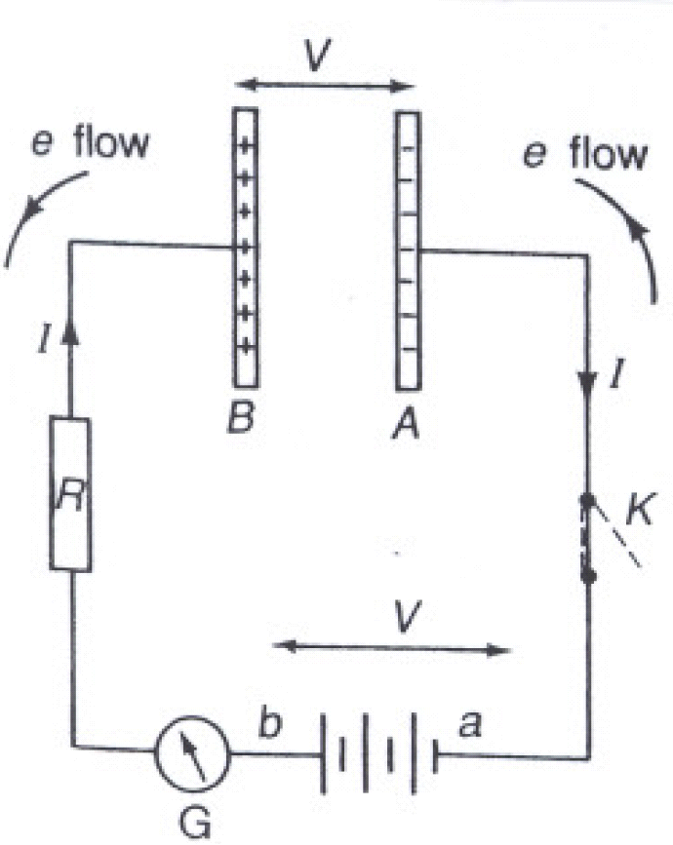
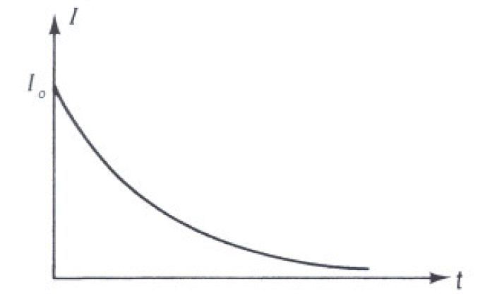

Discharging of a parallel plate capacitor:
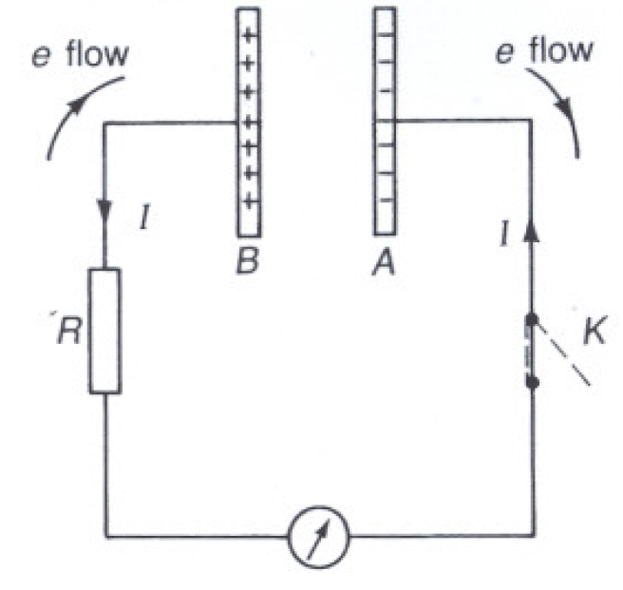
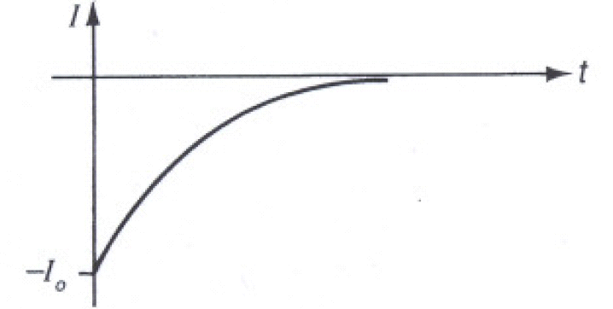

(C) Real-life application for control group:
The flash unit for a camera contains a capacitor which stores electrical energy. A capacitor has two terminals connected to two metal plates separated by a dielectric. The dielectric can be air, paper, plastic or anything else that does not conduct electricity and keeps the plates from touching each other.
Electric energy from a battery is used to charge the big flash capacitor which is permanently connected to two electrodes in a glass tube ("bulb") filled with xenon gas. At this stage, the gas does not conduct electricity and emits no light. Another, small capacitor is charged at the same time as the big one. When the flash unit needs to fire, this small capacitor is discharged through a transformer, which generates a pulse of very high voltage (several thousands of volts). This voltage is applied to a third electrode in the xenon tube. The high-voltage pulse causes the gas to ionize. Ionization makes the gas conductive, and the big capacitor starts to discharge through the xenon gas. Bright light is emitted by the xenon gas during this process. Since the resistance of the gas is very low at this stage, the discharge is rapid (about 1 ms to 5 ms) with the current following an exponential curve. When the voltage across the capacitor drops to a low value, the xenon stops conducting electricity, and the light pulse dies off. At this point, the charging process of the capacitor can be started from the beginning.
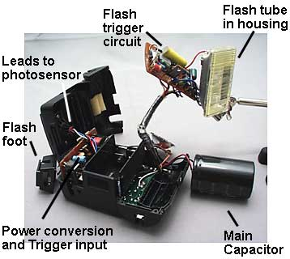
Apparatus:
2 identical flash units, dry cells, video camera, LCD projector, radial electrolytic capacitor with positive terminal marked marked metal filmed resistor of 20 kΩ, DC voltmeter of resistance at least 100 kΩ suitable for measuring 0 – 10 V, DC supply of emf about 9 V, 2 switches, 3 wires with bare ends, 6 wires with crocodile clip at one end.
Demonstration set-up:
With the help of a video camera linked to a LCD projector, show the 2 flash units, one in working condition & one dissected to show the circuitry containing the capacitor position.

Kindly refer to hardcopy for coloured picture
Kindly refer to hardcopy for coloured picture

Flash unit for a camera Inside of a flash unit
For safety reason, show the charging and discharging process with the help of the following circuit:
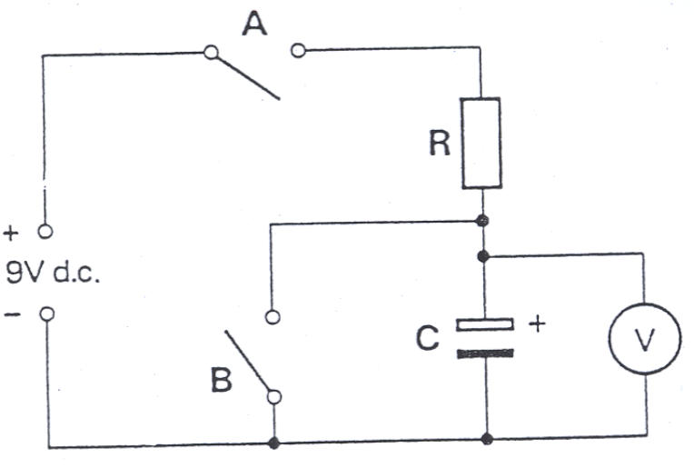

(D) Real-life application for experimental group:
Scenario 1
When an isolated surviving frog skin is placed in contact with two identical bathing solutions (such as Ringer solution) on both sides, it is able to generate an electrical potential difference which may exceed 100 mV. This electric asymmetry across the skin is due to an active transport of positive sodium ions across the skin (epithelium) from the outside chamber to the inside chamber leaving the negative chloride ions behind. The potential difference will approach a maximum limiting value.

Outside Cell of frog skin Inside
chamber chamber
Na⁺ Na⁺ Na⁺
Ringer
solution
Ringer
solution
Cl⁻ Na⁺
Cl⁻ Na⁺

multimeter
V

Electrical circuit equivalent of the above frog skin cell is:
R _{Σ}
R_{Na}
E_{Na}
V

R _{Σ}: skin resistance towards the passively transported ions
R _{Na} : skin resistance towards the actively transported sodium ions
E_{Na} : electromotive force of sodium pump
A typical terminal voltage across the frog skin cell, V is found to be around 75 mV

By means of an external source of emf connected to a variable resistor and ammeter, the electrical circuit of the frog skin cell is short-circuited as follows:
A
V
V₁
V₂
R _{Σ}
R_{Na}
E_{Na}
E
R

Adjust the variable resistance until the two opposing terminal voltages V₁ and V₂ cancels out to give a voltmeter reading of V = 0 V
Apparatus: Ringer solutions, 2 multimeters set to 200 mV and 200 μA, 4 long connecting leads, variable resistor, two chambers with connecting screws, droppler, petri dish, a pair of pincers & scissors, long sharp pin, live bull frog

Demonstration set-up:
Kindly refer to hardcopy for coloured picture

Chambers filled with ringer solution to hold the frog skin
Kindly refer to hardcopy for coloured picture

For a typical bull frog, the terminal voltage across the frog skin capacitor is found
to be about 75 mV

Kindly refer to hardcopy for coloured picture

& the circuit current is about 200 μA when V =
When the voltmeter reads zero volts, the current is found to be about 200 μA

Scenario 2
Constructing a parallel plate capacitor using a semi-permeable membrane
When two identical solutions of different concentrations are separated by a semi-permeable membrane, diffusion occurs over time. In the case of two potassium chloride (KCl) solutions of different concentrations are separated by a membrane which allows only the K⁺ ions to pass through, the rate of diffusion of K⁺ ions from the higher concentration side (H) to the lower concentration side (L) is higher than the rate of diffusion of K⁺ ions from the lower concentration side to the higher concentration side. A charge difference (dipole layer) and hence potential difference will be set up across the membrane over time. This dipole layer will provide an electrical force that tends to keep the K⁺ ions on the higher concentration side (H). An equilibrium condition is produced when the K⁺ ion movement due to diffusion is balanced by the ion movement due to the electrical force from the dipole layer. The membrane with a potential difference creates a ‘capacitor’ with a dielectric between them.
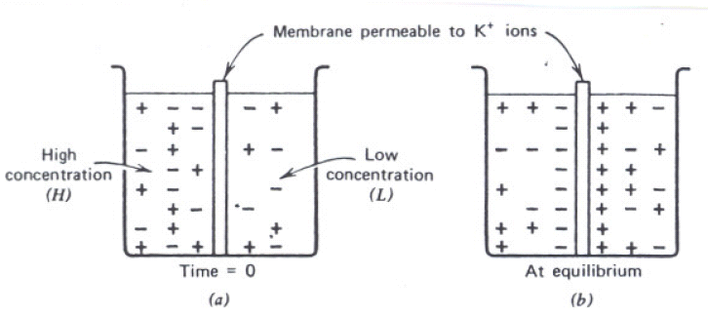
Apparatus: NaCl solutions of two different concentrations, multimeters set to 200 mV, 2 long connecting leads, two chambers with connecting screws, dead frog skin.

Demonstration set-up:
Kindly refer to hardcopy for coloured picture

Chambers filled with NaCl solutions of different concentrations to hold the dead frog skin
Kindly refer to hardcopy for coloured picture

For a typical bull frog, the voltage across the dead frog skin capacitor is found
to be about 60 mV

Appendix B: Data Collection Questions

- What are the pre-test physics achievement scores before undergoing physics demonstrations with and without the infusion of biology for:
(i) high and low ability students, based on initial college entry scores?
(ii) males and females?
- What are the pre-test physics attitude scores before undergoing physics demonstrations with and without the infusion of biology for:
(i) high and low ability students?
(ii) males and females?
- What are the post-test physics achievement scores after undergoing physics demonstrations with and without the infusion of biology for:
(i) high and low ability students?
(ii) males and females?
- What are the post-test physics attitude scores after undergoing physics demonstrations with and without the infusion of biology for:
(i) high and low ability students?
(ii) males and females?
- At post-test, taking into account the pre-test scores, is there a significant difference in the achievement of students who received biology-infused and non biology-infused physics demonstrations? That is, is there a main effect of using such demonstrations on students’ achievement?
- At post-test, is there a significant difference in the attitudes of students who received biology-infused and non biology-infused physics demonstrations? That is, is there a main effect of using such demonstrations on students’ attitudes?
- At post-test, taking into account the pre-test scores, does the magnitude or direction of the effect of this approach on achievement differ across:
(i) high and low ability students?
(ii) males and females?
That is, are there any interaction effects of using such demonstrations with ability level or gender in determining post-test achievement levels?
- At post-test, does the magnitude or direction of the effect of using such demonstrations on attitudes differ across:
(i) high and low ability students?
(ii) males and females?
That is, are there any interaction effects of using such demonstrations with ability level or gender in determining post-test attitude levels?

Appendix C: Physics Achievement Tests (PATs)

COLLEGE A/B

MULTIPLE CHOICE TEST (SET 1)

PHYSICS (9248)

Duration : ____

Name: _______________________________ Age :_____ Gender: M / F

Name of college: ___________________________________ Class :_____

L1R5 entry score: _______

INSTRUCTIONS TO PUPILS :-

1. Do not turn over until you are told to do so.

2. There is a total of 30 MCQs in this achievement test. You are required to attempt all of them in the brackets provided. For all questions, take g = 9.81 Nkg⁻¹

Each question carries 1 mark. No mark will be deducted for wrong answer.

S/No | Topics covered
1 | Forces
2 | Dynamics
3 | Electric Field
4 | Capacitance
5 | Current Electricity

SECTION 1: COMMON BACKGROUND KNOWLEDGE
- The force diagrams show all the forces acting on a beam of length 3x.
Which force system causes only rotational motion of the beam without any linear movement?
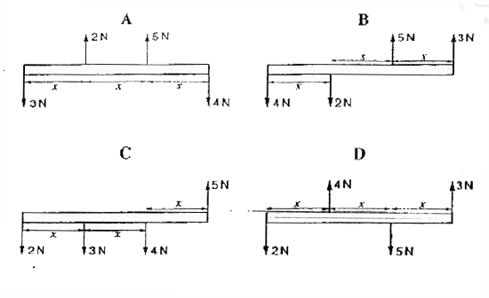

- A heavy uniform beam of length l is supported by two vertical cords as shown.
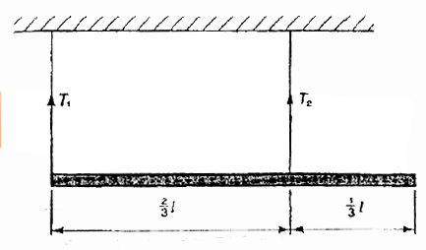
What is the ratio 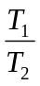of the tensions in these cords?
A
B 
C 
D
- A pendulum bob hangs from the ceiling in a carriage in a train and is just above a certain mark on the floor when the train is at rest. When the train is moving with constant velocity forwards, the bob

A is behind the mark, so that the pendulum thread is along the resultant of the forces due to the motion of the train and gravity.
B remains over the mark because the force due to the motion of the train is balanced by the reaction of the thread on the support.
C oscillates with simple harmonic motion about its former position because of the unbalanced force due to the motion of the train.
D remains over the mark because the net force on the bob with respect to the stationary observer in the horizontal direction is zero..

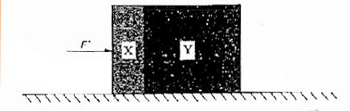
- Two blocks X and Y, of masses m and 3m respectively, are accelerated along a smooth horizontal surface by a force F applied to block X as shown.

What is the magnitude of the force exerted by block X on block Y during this acceleration?
A 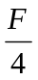
B 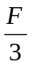
C 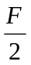
D 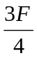

- A small metal sphere has radius r of 1.8 mm and is falling at a constant speed v of 28 mms⁻¹ through a liquid of density 1800 kg m⁻³. The density of the metal of the sphere is 7700 kg m⁻³.
The sphere is falling through the liquid under conditions of streamline flow. The drag force F on the sphere is given by

F = 6π r η v,

where η is the viscosity, in kg m⁻¹ s⁻¹, of the liquid.

Calculate the viscosity of the liquid.

A 0.454
B 1.50
C 1.94
D 2.40

- A cell of e.m.f E delivers a charge Q to an external circuit.
Which statement is correct?

A The energy dissipation in the external circuit is EQ.
B The energy dissipation within the cell is EQ.
C The external resistance is EQ.
D The total energy dissipation in the cell and the external circuit is EQ.

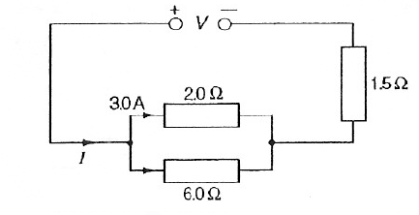
- In the circuit shown, there is a current of 3.0A in the 2.0Ω resistor.
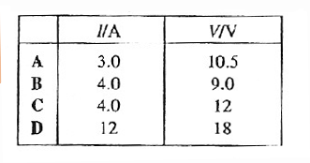
What are the values of the current I delivered by the power supply and the terminal voltage V across the power supply?

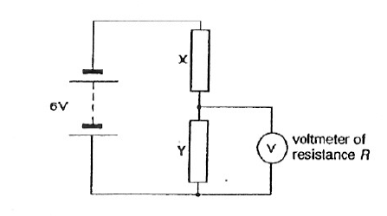
- In the circuit shown, resistors X and Y, each of resistance R, are connected to a 6V battery of negligible internal resistance. A voltmeter, also of resistance R, is connected across Y.

What is the reading of the voltmeter?
A between zero and 3V
B 3V
C between 3V and 6V
D 6V

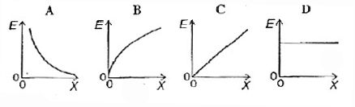
- Two parallel conducting plates are connected to a battery, one plate to the positive terminal and the other plate to the negative. The plate separation is gradually increased, the plates remaining connected to the battery. Which graph shows how the electric field E between the plates depends on the plate separation x?

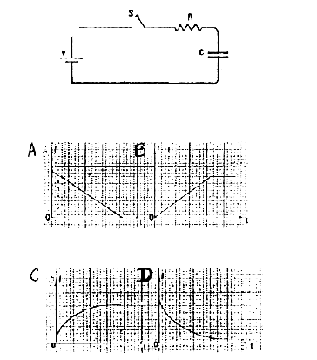

A circuit is set up as shown in Figure above with the capacitor C initially uncharged.

Which one of the following graphs represents the variation with time of the current I in the circuit when the switch S is closed?

SECTION 2: REAL-LIFE APPLICATIONS (WITHOUT BIOLOGY)

- The diagram shows a diving board held in position by two rods X and Y.

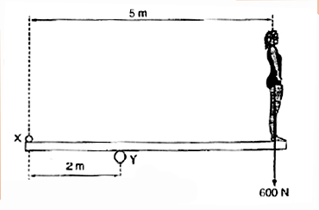
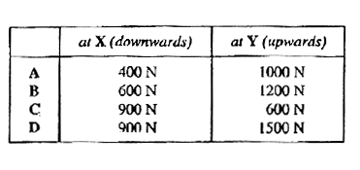
What forces do these rods exert on the board when a diver of weight 600 N stands on the right-hand end?

- A shop sign weighing 215 N is supported by a uniform 135 N beam as shown below. Find the magnitude of the tension in the guy wire.
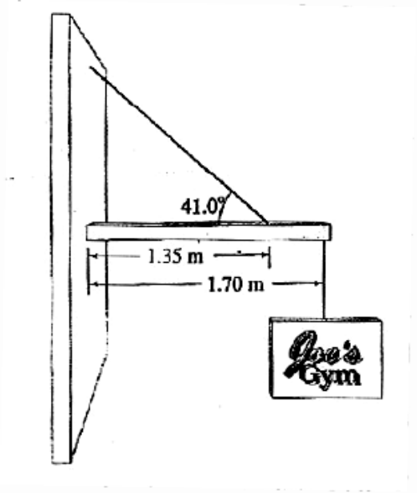
A 355 N
B 408 N
C 470 N
D 542 N

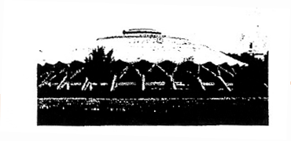

Consider the forces necessary to support a modern dome, that of the Small Sports Palace in Rome. A dome, like an arch, is statically most stable when under compression. The 36 buttresses which support the 1.2 x 10⁶ kg dome are positioned at a 38^{О} angle and connect smoothly with the dome.
Calculate the components of the force, F_{v} and F_{H} that each buttress exerts on the dome so that the force acts compressively – that is, at a 38^{О} angle.
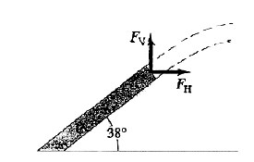
F_{v} F_{H}
A 3.3 x 10⁵ N 4.2 x 10⁵ N
B 1.2 x 10⁶ N 1.5 x 10⁶ N
C 3.3 x 10⁵ N 2.6 x 10⁵ N
D 1.2 x 10⁶ N 9.5 x 10⁵ N

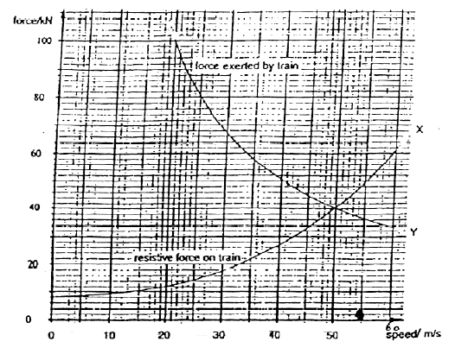
- When a train of railway carriages is moving, various forces resist the movement. Curve X shows the total resistive force on a train of carriages at different speeds as they run along a straight and level track. Curve Y shows the maximum force the engine can exert on the train at these speeds.
What will be the maximum speed of this train on a level track?

A 20 ms⁻¹
B 40 ms⁻¹
C 50 ms⁻¹
D 60 ms⁻¹
5. A helicopter of mass 5000 kg is rising with an acceleration of 2.4 ms⁻². What thrust must be exerted on it by its rotor?
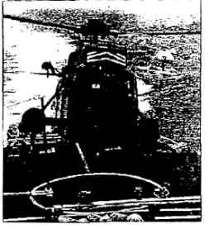

A 1.2 x 10⁴ N
B 3.7 x 10⁴ N
C 4.9 x 10⁴ N
D 6.1 x 10⁴ N

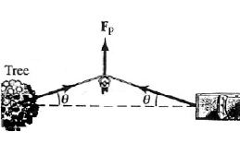
- Finding her car stuck in the mud, a bright graduate of a good physics course ties a strong rope to the back bumper of the car, and the other end to a tree, as shown below. She pushes at the midpoint of the rope with her maximum effort, which she estimates to be a force F_{p} ≈ 300 N. The car just begins to budge with the rope at an angle θ (see the figure) which she estimates to be 5º.
T
T

With what force T is the rope pulling on the car? Neglect the mass of the rope.

A 1.5 x 10² N
B 3.0 x 10² N
C 1.7 x 10³ N
D 3.4 x 10³ N
- Two masses suspended over a pulley by a cable, as shown in the below figure, is sometimes referred to generically as an Atwood’s machine. Consider the real-life application of an elevator (m₁) and its counterweight (m₂). To minimize the work done by the motor to raise and lower the elevator safely, m₁ and m₂ are similar in mass. We leave the motor out of the system for this calculation, and assume the cable’s mass is negligible and the pulley is frictionless and mass-less, which assures that the tension F_{T} in the cord has the same magnitude on both sides of the pulley. Let the mass of the counterweight be m₂ = 1000 kg.
Assume the mass of the empty elevator is 850 kg,
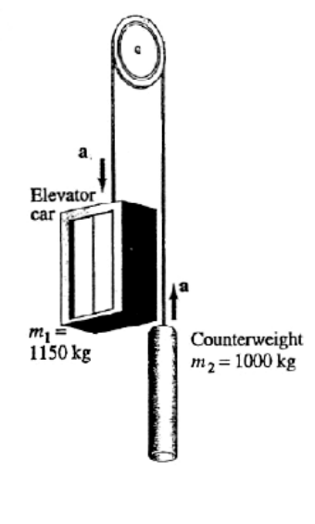
and its mass when carrying four passengers is m₁ = 1150 kg.

For the latter case (m₁ = 1150 kg), calculate the tension
in the cable.

A 9.11 x 10³ N
B 1.05 x 10⁴ N
C 1.21 x 10⁴ N
D 2.26 x 10⁴ N
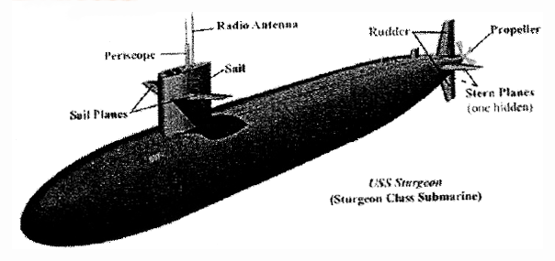

A submarine descends vertically at constant velocity. The three forces acting on the submarine are viscous drag, up-thrust and weight. Which relationship between their magnitudes is correct?

A weight < drag
B weight = drag
C weight < up-thrust
D weight > up-thrust

- An electrostatic copier works by selectively arranging positive charges (in a pattern to be copied) on the surface of a nonconducting drum, then gently sprinkling negatively charged dry toner (ink) particles onto the drum. The toner particles temporarily stick to the pattern on the drum and are later transferred to paper and “melted” to produce the copy.
Suppose each toner particle has a mass of 9.0 x 10⁻¹⁶ kg
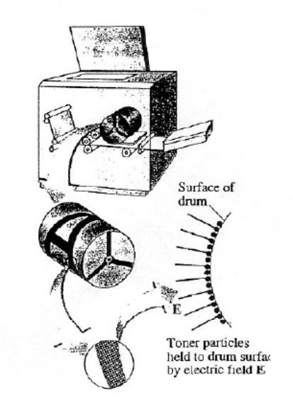
and carriers an average of 20 extra electrons to provide
an electric charge. Assuming that the electric force
on a toner particle must exceed twice its weight in order
to ensure sufficient attraction, compute the required
electric field strength near the surface of the drum.

A 2.8 x 10³ NC⁻¹
B 5.5 x 10³ NC⁻¹
C 5.5 x 10⁴ NC⁻¹
D 1.1 x 10⁵ NC⁻¹

10. In lightning storms, the potential difference between the Earth and the
bottom of thunderclouds can be as high as 35 million volts. The
bottom of the thunderclouds is typically 1500 m above the Earth’s
surface and can have an area of 110km².

Assuming the Earth-cloud system as a huge capacitor of capacitance 0.649 μF, calculate the charge stored in this huge “capacitor” and the electric field between the earth and the bottom of the thunderclouds.
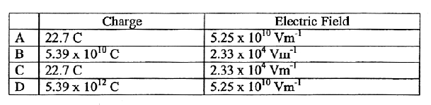
SECTION 3: REAL-LIFE APPLICATIONS (WITH BIOLOGY)

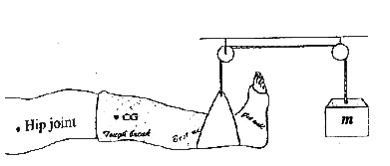
- Calculate the mass m needed in order to suspend the leg shown above. Assume the leg (with cast) has a mass of 15.0 kg and its CG is 35.0 cm from the hip joint; the sling is 85.0 cm from the hip joint; and the mass m are is 100.0cm from the hip joint.

A 2.91 kg
B 5.25 kg
C 6.52 kg
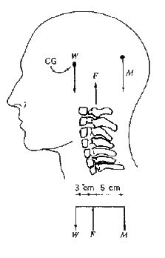
D 34.5 kg
- One first-class lever system involves the extensor muscle, which exerts a force M to hold the head erect: the force W of the weight of the head, located at its center of gravity (CG), lies forward of the force F exerted by the first cervical vertebra (see figure). The head has a mass of about 4 kg. Find F and M.
F M
A 6.4 N 2.4 N
B 53.9 N 14.7 N
C 62.7 N 23.5 N
D 104.6 N 65.4 N
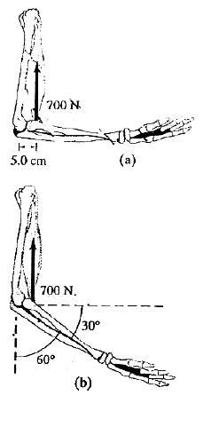

The biceps muscle exerts a vertical force on the lower arm as shown in figures (a) and (b).

For Figure (b), calculate the torque about the axis of rotation through the elbow joint, assuming the muscle is attached 5.0 cm from the elbow as shown in Figure (a).

A 17.5 Nm
B 20.2 Nm
C 30.0 Nm
D 35.0 Nm

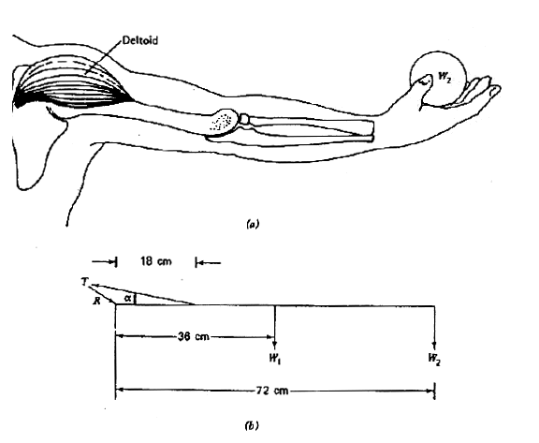

In the raising of the arm in Figure (a), the forces in Figure (b) are: T is the tension in the deltoid muscle fixed at the angle α, R is the force on the shoulder joint, W₁ is the weight of the arm located at its center of gravity, and W₂ is the weight in the hand. Given that α = 16⁰, W₁ = 68 N, W₂ = 45 N, find T.

A 329 N
B 1102 N
C 1146 N
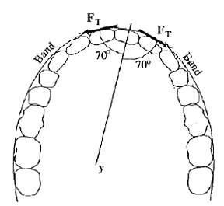
D 1313 N

- The wire band shown in the figure has a tension F_{T} of 2.0 N along it. It therefore exerts forces of 2.0 N on the tooth (to which it is attached) in the two directions shown. Calculate the magnitude of the resultant force on the tooth due to the wire, F_{w.}

A 0.68 N
B 1.36 N
C 1.88 N
D 3.76 N

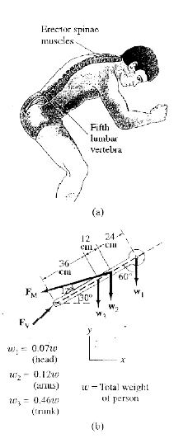

The lowest vertebra on the spinal column acts as a fulcrum for this particular bending position. The “erector spinae” muscles in the back that support the trunk act at an effective angle of about 12º to the axis of the spine. Figure (b) is a simplified schematic drawing showing the forces on the upper body. We assume the trunk makes an angle of 30º with the horizontal.

The force exerted by the back muscles is represented by F_{m,} the force exerted on the base of the spine at the lowest vertebra is F_{v,} and w₁, w₂, and w₃ represent the weights of the head, freely hanging arms, and trunk, respectively.

Calculate the magnitude of F_{m} in terms of w.

A 0.29 w
B 1.39 w
C 2.37 w
D 4.64 w

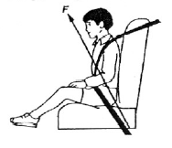
- A child (mass m) sits on a car seat which is accelerating horizontally at 0.50 g (where g is the acceleration of free fall).

What is the magnitude of the total force F exerted by the car seat on the child?

A 0.50 mg
B 1.0 mg
C 1.1 mg
D 1.5 mg

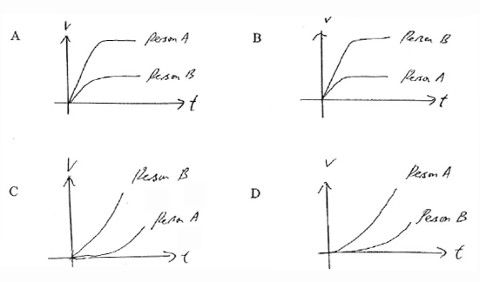
- Person A is suffering from gout where the red blood cells clump together while person B is suffering from hemolytic jaundice where the red blood cells break up. If the blood samples of persons A and B are dropped into a solution to study their terminal (sedimentation) velocities, which of the following v-t graphs is correct?

- When an isolated surviving frog skin is placed in contact with two identical bathing solutions (such as Ringer solution) on both sides, it is able to generate an electrical potential difference. For the question below, the p.d. V is found to be 75 mV.

The electrical circuit equivalent of the frog skin cell is:
R _{Σ}
R_{Na}
E_{Na}
V

R _{Σ}: skin resistance towards the passively transported ions R _{Na} : skin resistance towards the actively transported sodium ions
E_{Na} : electromotive force of sodium pump
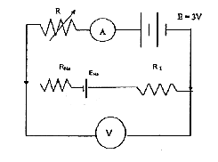
An external source of emf 3 V connected to a variable resistor and ammeter is then connected to the electrical circuit of the frog skin cell as follows:

The variable resistor is increased from zeros lowly until the voltmeter reading is zero. If the ammeter reading is 200 μA, what is the value of the resistance of the variable resistor used?

A 3.75 x 10² Ω
B 1.46 x 10⁴ Ω
C 1.50 x 10⁴ Ω
D 1.54 x 10⁴ Ω

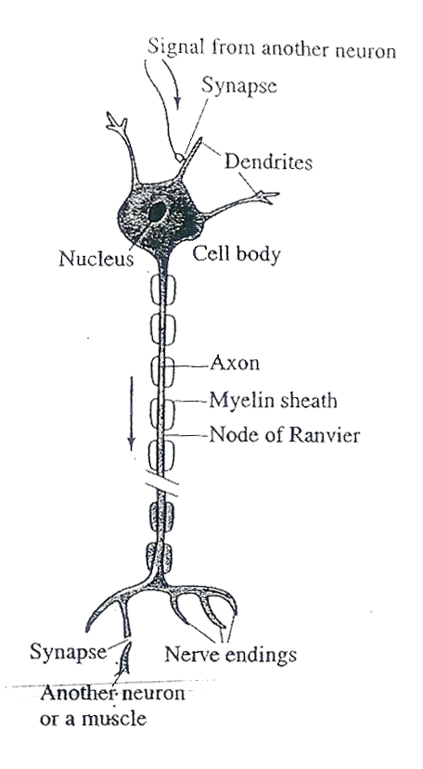
10.A neuron, before transmitting an electrical signal, is in the so-called “resting state”. Like nearly all living cells, neurons have a net positive charge on the outer surface of the cell membrane and a negative charge on the inner surface. The most important aspect of a neuron is not that it is a resting potential (most cells do), but rather that it can respond to a stimulus and conduct an electrical signal along its lengthy. The membrane of an axon resembles a cylindrically shaped parallel-plate capacitor, with opposite charges on each side.
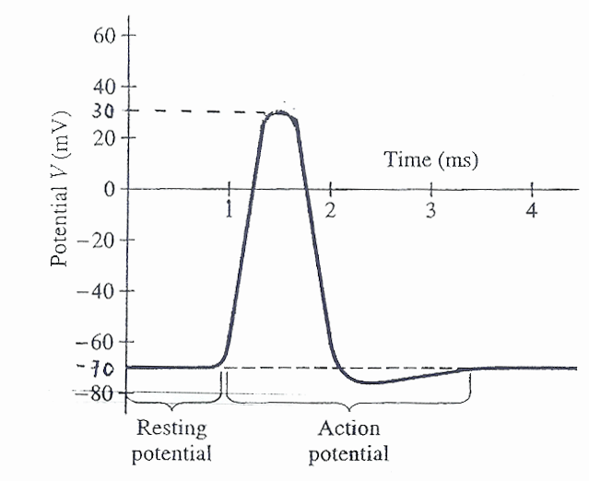
Given that the capacitance of an axon is 10 nF, what is the amount of charge that moves in one action potential from -70 mV to 30 mV?

A 3.0 x 10⁻¹⁰ C
B 7.0 x 10⁻¹⁰ C
C 1.0 x 10⁻⁹ C
D 1.0 x 10⁻⁸ C

COLLEGE A/B

MULTIPLE CHOICE TEST (SET 2)

PHYSICS (9248)

Duration : ____

Name: _______________________________ Age :_____ Gender: M / F

Name of college: ___________________________________ Class :_____

L1R5 entry score: _______

INSTRUCTIONS TO PUPILS :-

1. Do not turn over until you are told to do so.

2. There is a total of 30 MCQs in this achievement test. You are required to attempt all of them in the brackets provided. For all questions, take g = 9.81 Nkg⁻¹

Each question carries 1 mark. No mark will be deducted for wrong answer.

S/No | Topics covered
1 | Forces
2 | Dynamics
3 | Electric Field
4 | Capacitance
5 | Current Electricity

SECTION 1: COMMON BACKGROUND KNOWLEDGE
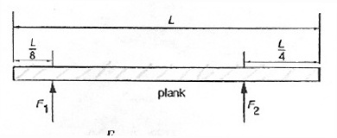
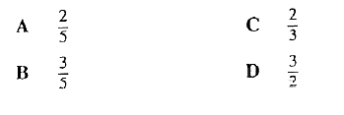
- A heavy uniform plank of length L is supported by two forces F₁, and F₂ at points distant  and from its ends as shown.
What is the value of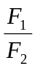?
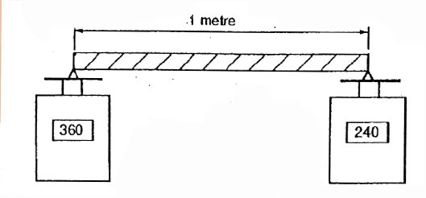
- A rod of length 1 meter has non-uniform composition, so that the centre of gravity is not at its geometrical centre. The rod is laid on supports across two top-pan balances as shown in the diagram. The balances (previously set at zero) give readings of 360g and 240g.
Where is the centre of gravity of the rod relative to its geometrical centre?
A 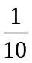 metre to the left
B metre to the right
C metre to the left
D metre to the right

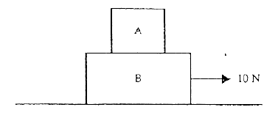
- Two objects, A of mass 3.0 kg and B of mass 2.0 kg are stacked with one on top of the other as shown in the figure. If all the surfaces are regarded as frictionless, what is the acceleration of A when B is being pulled by a horizontal force of 10 N?
A 0 m s⁻²
B 2.0 m s⁻²
C 3.0 m s⁻²
D 5.0 m s⁻²

- Newton’s third law concerns the forces of interaction between two bodies. Which of the following statements relating to the third law is not correct?
A The two forces must be of the same type.
B The two forces are always opposite in direction.
C The two forces are at all times equal in magnitude.
D The two forces are equal and opposite so the bodies are in equilibrium.

- Stoke’s law for the viscous force F acting on a sphere of radius a falling with velocity v through a large expanse of fluid of coefficient of viscosity η is expressed by the equation
F = 6πaηv

A sphere released in a fluid will fall with diminishing acceleration until it attains a constant terminal velocity. Calculate this velocity for an oil drop of radius 3.0 x 10⁻⁶m falling through air of coefficient of viscosity 1.8 x 10⁻⁵ Pas, given that the density of the oil is 8.0 x 10² kg m⁻³ and that the density of air may be neglected.
A 8.72 x 10⁻² kg ms⁻¹
B 2.67 x 10⁻⁴ kg ms⁻¹
C 1.57 x 10⁻⁸ kg ms⁻¹
D 1.36 x 10⁻⁹ kg ms⁻¹

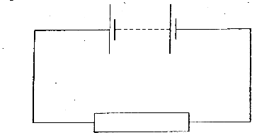
- In the circuit below, the battery converts an amount E of chemical energy to electrical energy when charge Q passes through the resistor in time t.
Which expressions give the e.m.f. of the battery and the current in the resistor?
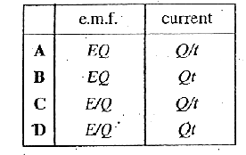
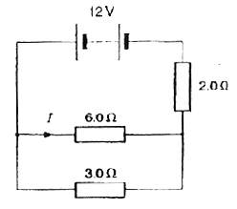
- The diagram shows a circuit in which the battery has negligible internal resistance.
What is the value of the current I?
A 1.0 A
B 1.6 A
C 2.0 A
D 3.0 A

- In the circuit, a 10.0 V supply of negligible internal resistance is joined to two 30 kΩ resistors in series. A voltmeter of resistance 60 kΩ is connected in parallel with one of the resistors.
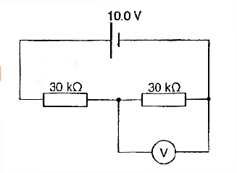
What is the reading on the voltmeter?
A 4.0 V
B 5.0 V
C 6.0 V
D 6.7 V

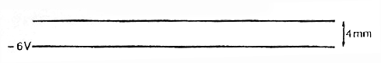
- Two large horizontal metal plates are separated by a 4 mm. The lower plate is at a potential of -6 V.
What potential should be applied to the upper plate to create an electric field of strength 4000 V m⁻¹ upwards in the space between the plates?
A +22 V
B +10 V
C –10 V
D –22V

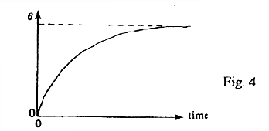
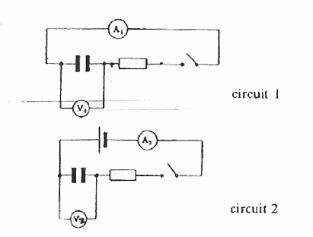
- In circuit 1, a charged capacitor discharges when the switch is closed. In circuit 2, an uncharged capacitor is charged when the switch is closed. When the switches are closed, one of the five meters gives a reading θ which varies with time, as shown below.
Which meter records in this way?
A A₁
B A₂
C V₁
D V₂

SECTION 2: REAL-LIFE APPLICATIONS (WITHOUT BIOLOGY)

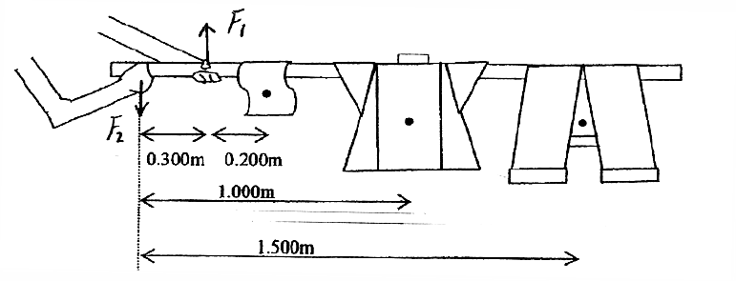
1. A housewife is hanging out the laundry for drying. The trousers and shirt and towel have masses 3.00 kg, 1.00 kg, 0.20 kg respectively. The housewife put her left hand at a distance of 0.300 m from the near end while her right hand is holding the near end of the rod as shown below.
The centre of mass of the towel, the shift, and the trousers is at 0.500 m, 1.000 m, and 1.500 m away from the near end of the housewife. Calculate the force exerted by each of her hands acting perpendicularly on the rod.
F₁ F₂
A 150 N 109 N
B 181 N 140 N
C 183 N 142 N
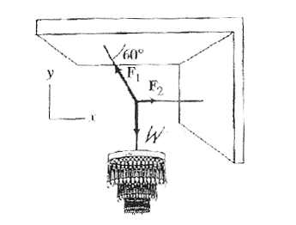
D 109 N 150 N
- Calculate the tensions F1 and F2 in the two cords that are connected to the cord supporting the 200 kg chandelier.
F₁ F₂
A 1132 N 560 N
B 2260 N 1130 N
C 3920 N 1960 N
D 3920 N 3394 N
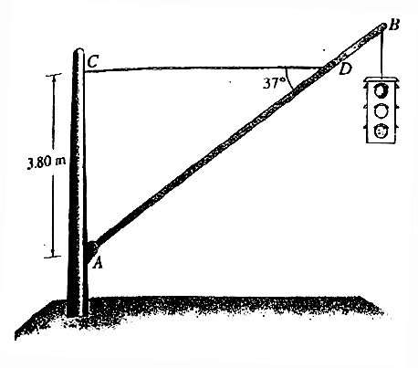
3.
A traffic light hangs from a structure as shown above. The uniform aluminium pole AB is 7.5 m long and has a mass of 8.0 kg. The mass of the traffic light is 12.0 kg. Determine the tension in the horizontal massless cable CD exerted by the pivot A on the aluminum pole.
A 186 N
B 233 N
C 239 N
D 247 N
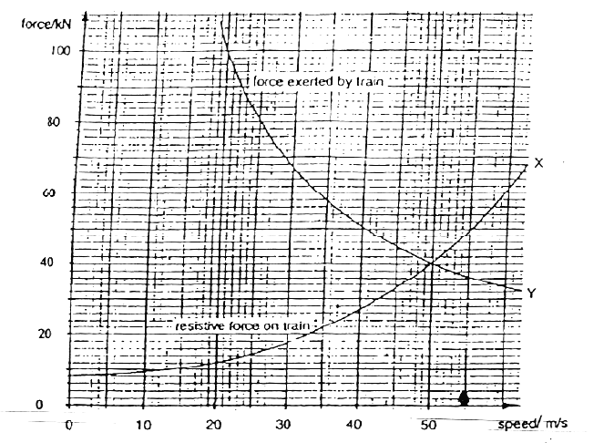
4. When a train of railway carriages is moving, various forces resist the movement. Curve X shows the total resistive force on a train of carriages at different speeds as they run along a straight and level track. Curve Y shows the maximum force the engine can exert on the train at these speeds.
The carriages have a total mass of 400 x 10³ kg. Calculate the maximum acceleration of the train when the speed is 20 m/s.
A 0.22 x 10⁻³ ms⁻²
B 0.25 x 10⁻³ ms⁻²
C 0.22 ms⁻²
D 0.25 ms⁻²
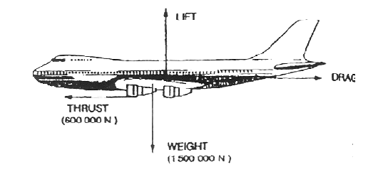
An aircraft in straight, level flight with a constant velocity has a total weight of 1.5 x 10⁶ N, and the engines give it a forward thrust of 0.60 x 10⁶ N, as shown below.
The resultant force acting on the aircraft is equal to
A the weight of the aircraft.
B the resultant of the air resistance and the thrust of the engines.
C the resultant of the air resistance and the weight of the aircraft.
D zero.

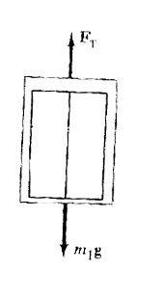

A lift has a mass of 1800 kg and the rope supporting it exerts an upward force on it of 15 000 N. What is the acceleration of the lift? If this lift is traveling upwards at a speed of 3.8 ms⁻¹, how long will it take to stop?
A 0.387 s
B 0.456 s
C 2.27 s
D 2.57 s

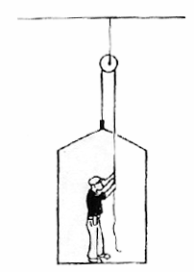
A man in the builder’s cradle is lifting himself upwards (there are safety devices not shown to prevent him falling). He has a mass of 80 kg and the cradle has a mass of 30 kg. He is pulling on the rope with a force of 600 N.

You can assume that the tension in the ripe is the same at both ends of the rope, so that it exerts both a force of 600 N upwards on the man and a force of 600 N upwards on the cradle. Find the acceleration of the man.
A 0.91 ms⁻²
B 1.10 ms⁻²
C 5.19 ms⁻²
D 10.9 ms⁻²
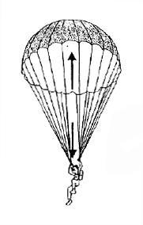
A parachutist of mass 70.0 kg falls with its terminal velocity. Which combination A to D gives its weight, the air resistance and the resultant force acting on him.

Weight Air resistance Resultant force
A 70.0 N down 70.0 N up zero
B 687 N down zero 687 N down
C 687 N down 687 N up zero
D 687 N down 687 N up 687 N down
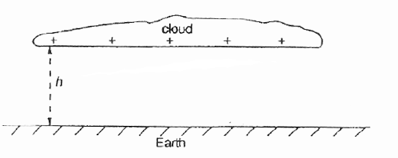
A thundercloud and the Earth’s surface may be regarded as a pair of charged parallel plates separated by a distance h as shown in the diagram. The capacitance of the system is C.
When a lightning flash of mean current I and time duration t occurs, the electric field strength between cloud and Earth is reduced by:
A 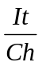
B 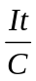
C 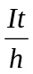
D CIt

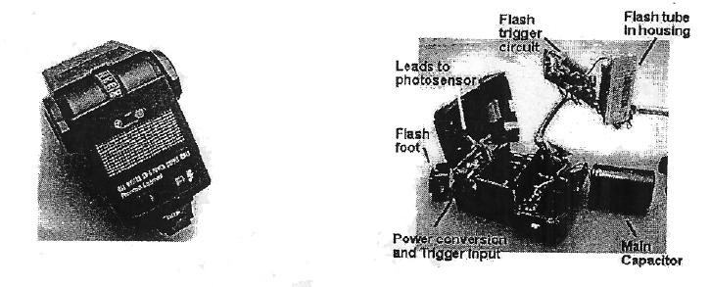
In a typical flash unit for a camera, electric energy from a battery is converted to high voltage and is used to charge a capacitor. The converter often makes a high-pitch sound which you can hear when the flash unit is charging. The figures below show a flash unit for a camera and its key components when opened up.
If the charging voltage is 400 V and the charge accumulated in the capacitor is 60 mC, what is the capacitance of the capacitor used in the flash unit?

A 1.5 x 10⁻⁴ F
B 2.4 x 10⁻² F
C 24 F
D 6.7 x 10³ F

SECTION 3: REAL-LIFE APPLICATIONS (WITH BIOLOGY)

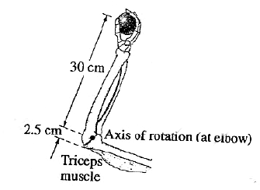
1.
The forearm in the above figure accelerates a 3.6 kg ball at 7.0 m/s² by means of the triceps muscle, as shown. Calculate the force that must be exerted by the triceps muscle. Ignore the mass of the arm.
A 2.10 N
B 7.56 N
C 25.2 N
D 302 N

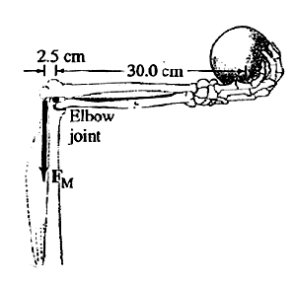
2.
Approximately what force, F_{m}, must the extensor muscle in the upper arm exert on the lower arm to hold a 7.3 kg shot put? Assume the lower arm has a mass of 2.8 kg and its CG is 12 cm from the pivot point.
A 7.3 x 10² N
B 8.6 x 10² N
C 9.9 x 10² N
D 1.0 x 10³ N

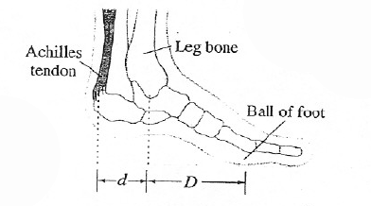
3. The Achilles tendon is attached to the rear of the foot as shown.
When a person elevates himself just barely off the floor on the “ball of one foot,” estimate the tension T in the Achilles tendon (pulling upward), and the (downward) force F exerted by the lower leg bone on the foot. Assume the person has a mass of 70 kg, and that D is twice as long as d.
T F
A 3.44 x 10² N 5.16 x 10² N
B 6.87 x 10² N 1.03 x 10³ N
C 1.37 x 10³ N 2.06 x 10³ N
D 2.75 x 10³ N 4.12 x 10³ N
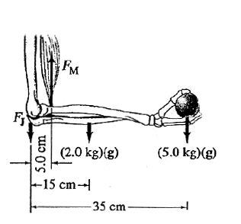
4.
How much force, F_{m}, must the biceps muscle exert when a 5.0 kg mass is held in the hand with the arm horizontal as in the figure? Assume that the mass of forearm and hand together is 2.0 kg and their CG is as shown. F_{J} is the force exerted at the joint by the bone in the upper arm.
A 202 N
B 337 N
C 349 N
D 351 N
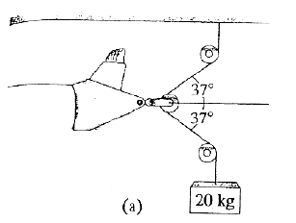
5.
Calculate the force exerted on the leg by the traction apparatus shown in the figure. Assume the pulleys are frictionless.
A 313 N
B 296 N
C 236 N
D 196 N

- A 50 kg person jumping from a height of 1 m is traveling at 4.5 m/sec just prior to landing. Suppose she lands on a pad and stops in 0.20 s. Calculate the average force exerted by the pad on her.
A 4.91 x 10² N
B 6.35 x 10² N
C 1.13 x 10³ N
D 1.62 x 10³ N
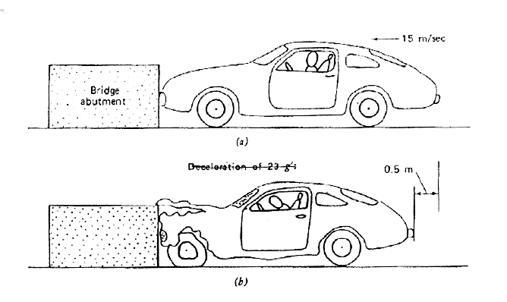
7.
An automobile of mass 1 ton traveling at 15 ms⁻¹ is involved in a collision and stops in 0.5 m. What is the average force exerted on the car by the bridge abutment?
A 225 N
B 2.25 x 10³ N
C 2.25 x 10⁴ N
D 2.55 x 10⁵ N
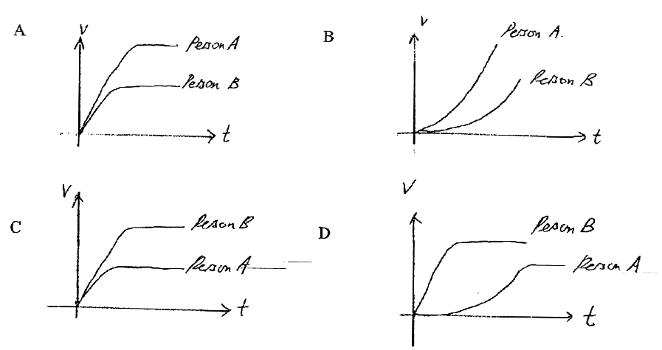
8. Medical studies show that the blood cells of a person A suffering from rheumatic fever clump together and the effective radius increases. If the blood samples of such a person and a healthy person B are dropped into a solution to study their terminal (sedimentation) velocities, which of the following v-t graphs is correct?
9. Suppose that a person’s body resistance is 900 Ω. What current I₁ passes through the body when the person accidentally is connected to 110V? If there is an alternative path from supply to ground whose resistance is 40 Ω, what current I₂ passes through the person?

I₁ I₂
A 0.122A 0.117A
B 0.122A 0.122A
C 0.122A 2.87A
D 2.75A 2.87A

10.A heart pacemaker is designed to operate at 72 beats/min using a 7.5 μF capacitor. When the voltage reaches a particular value, it discharges a current of 0.02 mA for a time interval of 0.8 s. What is the value of the particular voltage reached?

A 0.12 V
B 0.47 V
C 2.13 V
D 2.22 V

Appendix D: Test of Physics-Related Attitudes (TORPA)

Name: _______________________________ Age :_____ Gender: M / F

Name of college: ___________________________________ Class :_____

L1R5 entry score: _______

For each of the following statements below, kindly indicate with a tick (√ ) your response based on your feeling about the statement. There are no correct answers.

S/No | Statement | strongly disagree (SD) | Disagree  (D) | Agree (A) | strongly disagree (SA)
1 | I enjoy physics.
2 | Physics is one of my most interesting subjects.
3 | I look forward to physics lessons.
4 | Studying physics is a waste of time.
5 | The work is hard in physics lessons.
6 | I feel confused during physics lessons.
7 | The thought of physics makes me tense.

Appendix E: Affective Outcomes Scale (AOS)

All responses will be given on a four-point scale, with anchor points “Not At All” to “Very Much So”.

These demonstrations have:
- helped me better understand physics principles.
- made me more confident in my knowledge of physics.
- helped me to remember key ideas by applying them.
- made physics concepts less difficult to grasp.
- made physics more fun.
- increased my interest in the subject.
- made me want to know more about physics.
- increased my motivation to do the assigned work in physics.
- highlighted to me that physics is an important subject area.
- shown me how physics can be applied to solve important problems.
- shown me that physics has important connections with other subject areas.
- reminded me that physics can be used to solve real-world problems.

